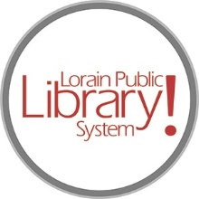
For more information, contact:
Jennifer Winkler, Branch Manager
JWinkler@lpls.info
or
Mark Peters, Assistant Branch Manager
MPeters@lpls.info
440-327-8326

LorainPublicLibrary.org

NORTH RIDGEVILLE PATRON UPDATE

August 27, 2023

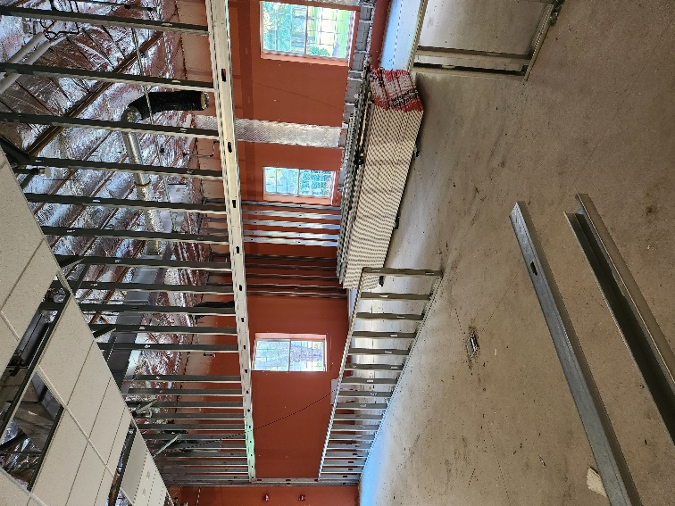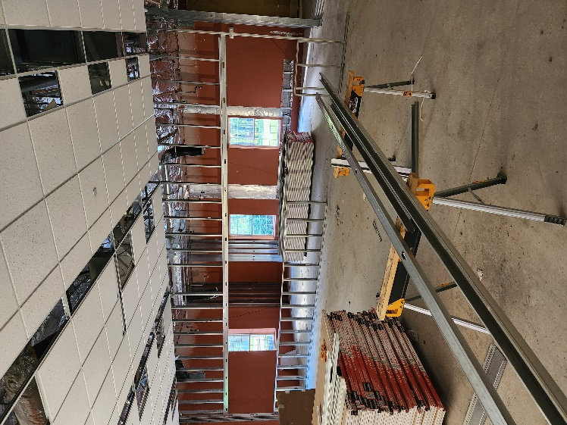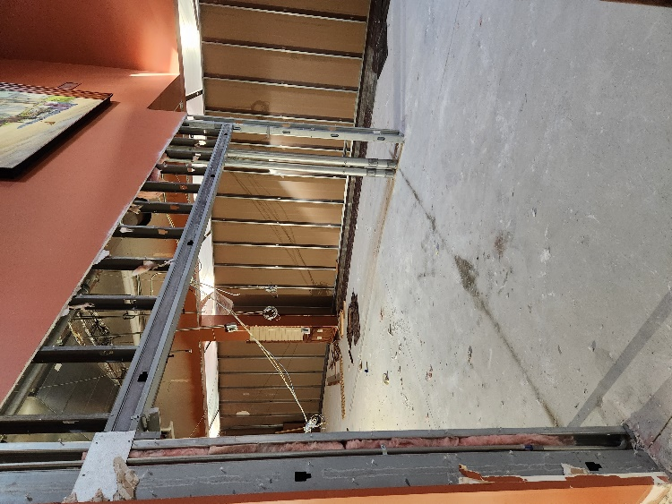
Demolition of phase one is complete! The carpenters are framing and the electricians are running conduit for data and electrical.
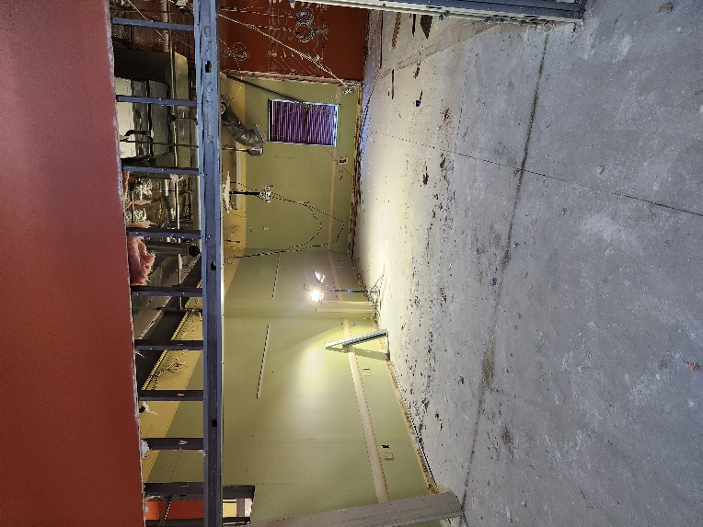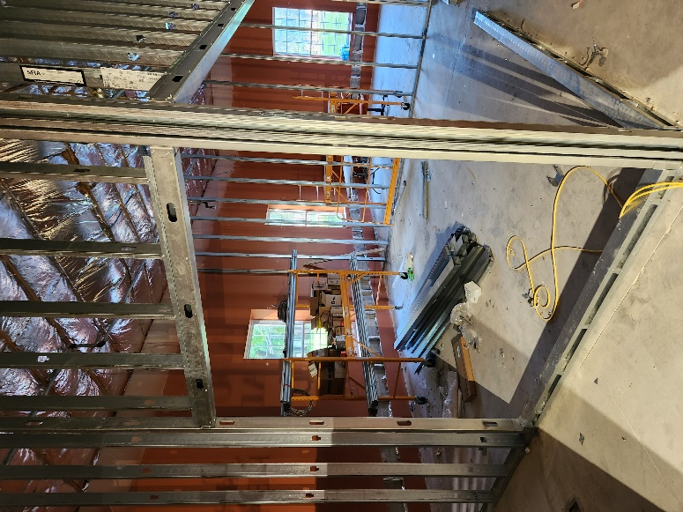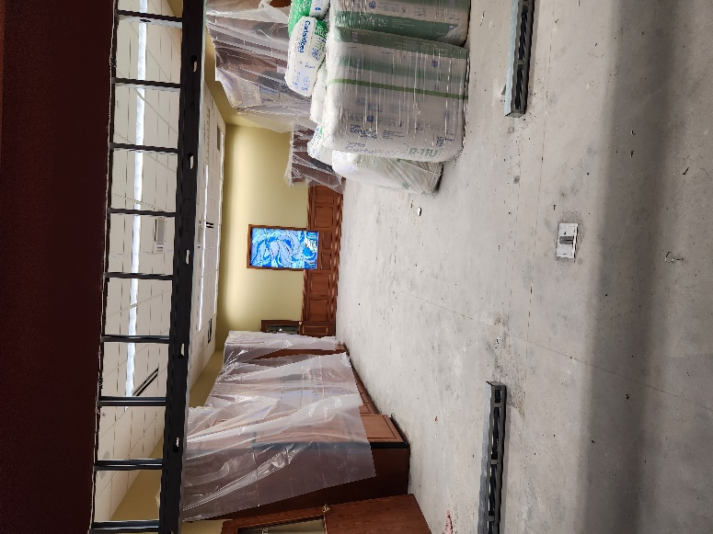
This will be the Create Space New Meeting Rooms Quiet Reading Room

As always, please contact the Branch Manager or Assistant Branch Manager with any questions or concerns.
Thank you for your patience through this renovation process!

###

