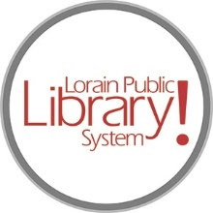
For more information, contact:
Jennifer Winkler, Branch Manager
JWinkler@lpls.info
or
Mark Peters, Assistant Branch Manager
MPeters@lpls.info
440-327-8326

LorainPublicLibrary.org

NORTH RIDGEVILLE PATRON UPDATE

Sept. 19, 2023

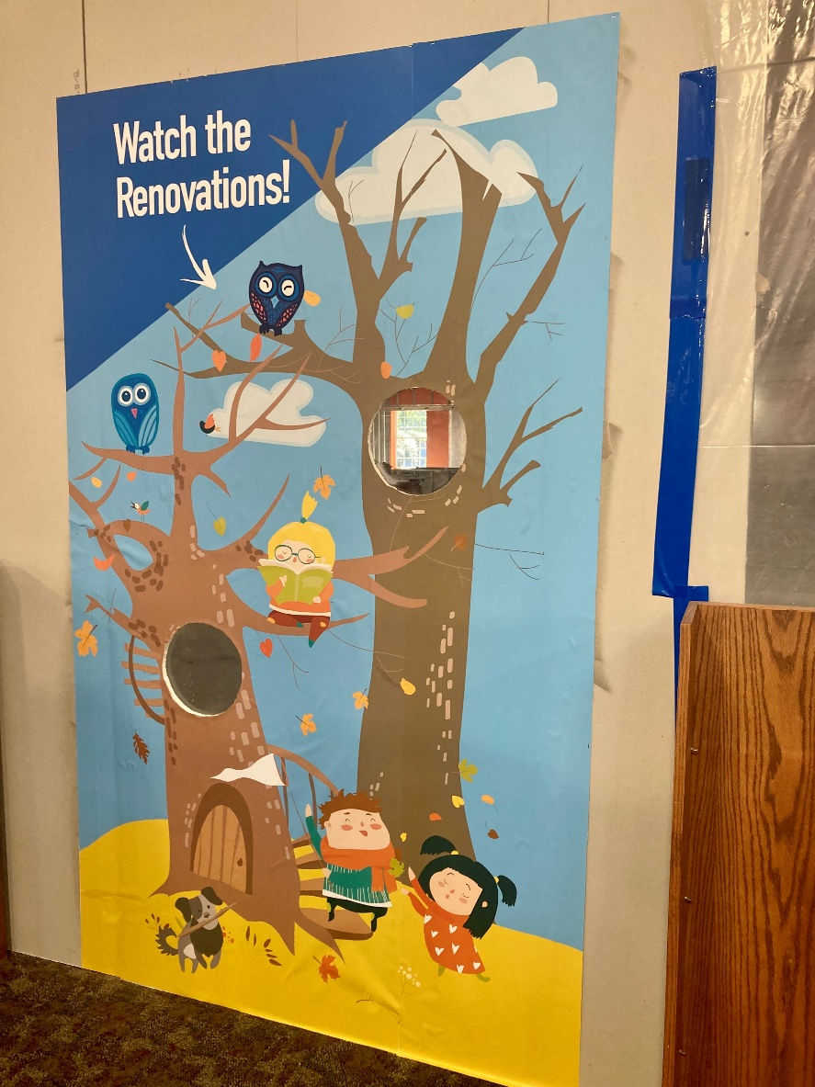

A fun graphic has been added to the construction wall windows! Stop by and watch the renovation progress.
Please contact the Branch Manager or Assistant Branch Manager with any questions or concerns. Thank you for your patience through this renovation process!
###

