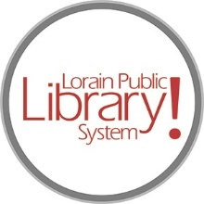
For more information, contact:
Jennifer Winkler, Branch Manager
JWinkler@lpls.info
or
Mark Peters, Assistant Branch Manager
MPeters@lpls.info
440-327-8326

LorainPublicLibrary.org

NORTH RIDGEVILLE PATRON UPDATE

September 12, 2023

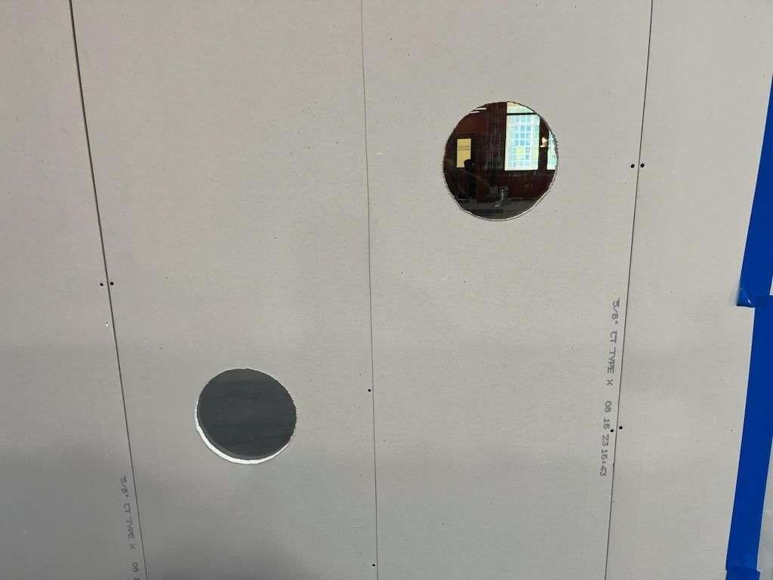

What is going on back there? We wanted to know and thought you might too, so we asked our awesome maintenance team to please cut some windows in the temporary construction wall at adult and child height. Now we can all watch the renovation progress. Our graphics guru is working on a fun design…stay tuned!
Please contact the Branch Manager or Assistant Branch Manager with any questions or concerns. Thank you for your patience through this renovation process!
###

