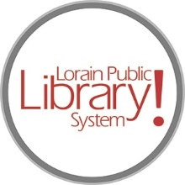
For more information, contact:
Jennifer Winkler, Branch Manager
JWinkler@lpls.info
or
Mark Peters, Assistant Branch Manager
MPeters@lpls.info
440-327-8326

LorainPublicLibrary.org

NORTH RIDGEVILLE PATRON UPDATE

October 3, 2023

Having a hard time envisioning the revised spaces? This should help:
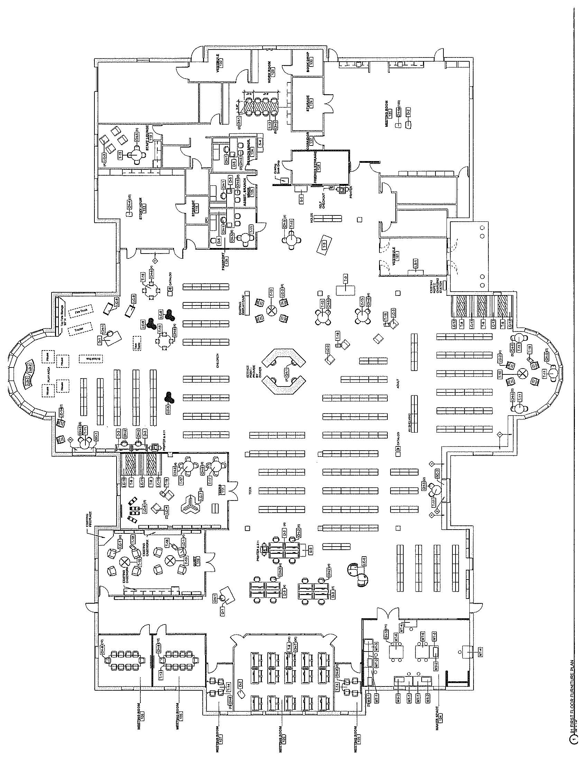

As always, please contact the Branch Manager or Assistant Branch Manager with any questions or concerns.
Thank you for your patience through this renovation process!

###

