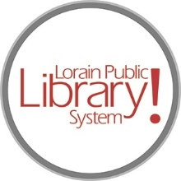

*For more information, contact:*

Jennifer Winkler, Branch Manager

[JWinkler@lpls.info](mailto:JWinkler@lpls.info)

or

Mark Peters, Assistant Branch Manager

[MPeters@lpls.info](mailto:MPeters@lpls.info)

440-327-8326

[LorainPublicLibrary.org](http://www.lorainpubliclibrary.org/)

**NORTH RIDGEVILLE PATRON UPDATE**

October 31, 2023

The four canvas murals of historic North Ridgeville have been temporarily removed. We are working with a third-party vendor to preserve, clean and store these pieces until they can be safely reinstalled once renovations are complete.

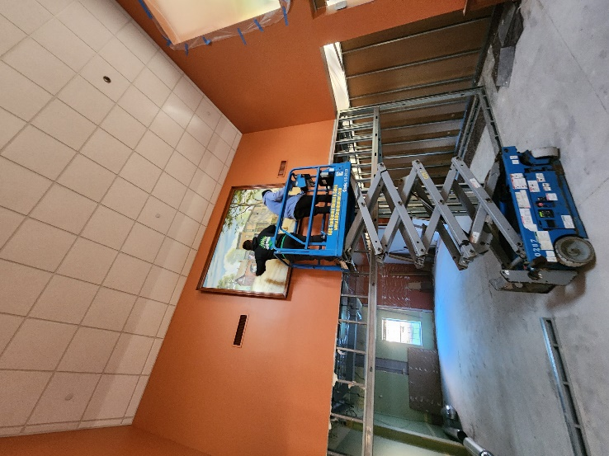 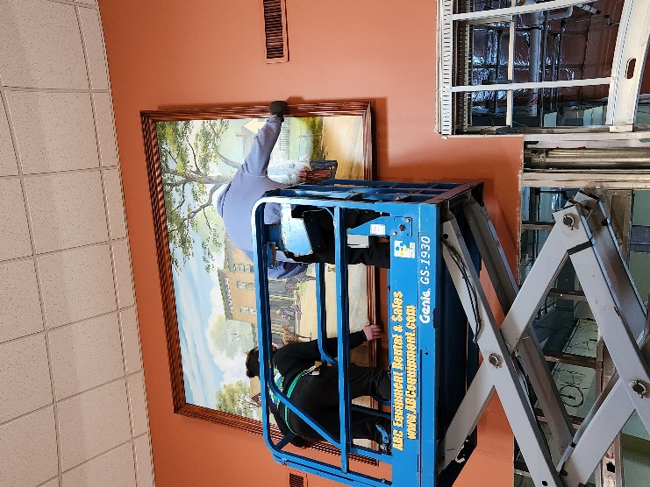 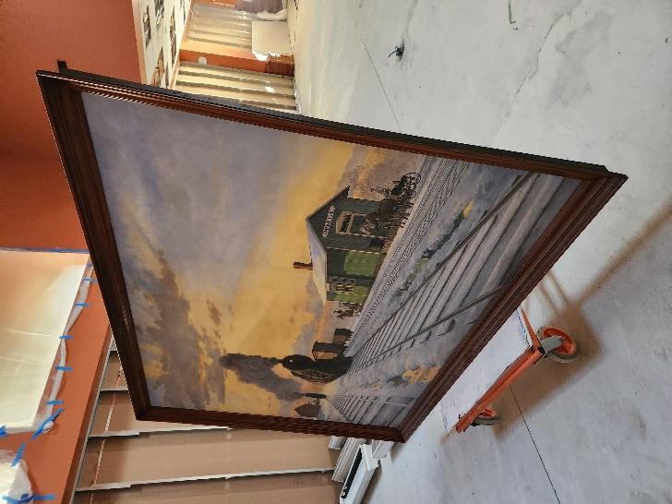

Also this week the crew has been power-washing the exterior of the building to remove the efflorescence, a buildup of salt and minerals that occur when moisture seeps through the brick.

As always, please contact the Branch Manager or Assistant Branch Manager with any questions or concerns.

Thank you for your patience through this renovation process!

###[](https://www.tiktok.com/discover/lorainplsystem)[](https://twitter.com/LorainPLSystem)[](https://www.facebook.com/LorainPublicLibrarySystem/)[](https://www.instagram.com/LorainPLSystem/)