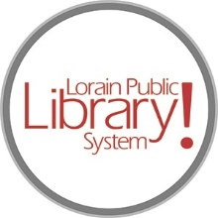
For more information, contact:
Jennifer Winkler, Branch Manager
JWinkler@lpls.info
or
Mark Peters, Assistant Branch Manager
MPeters@lpls.info
440-327-8326

LorainPublicLibrary.org

NORTH RIDGEVILLE PATRON UPDATE

October 24, 2023

There is not a lot to report this week. The crew is still waiting for some electrical supplies to come in so they can finish the electric rough-in. “Rough-in” wiring means all the electrical cables have been pulled through the studs of the wall and that boxes for light switches, outlets and receptacles have been placed.

Once that is done, there will be a framing inspection and then they can start hanging drywall!

As always, please contact the Branch Manager or Assistant Branch Manager with any questions or concerns.
Thank you for your patience through this renovation process!

###

