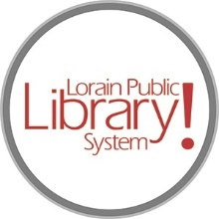
For more information, contact:
Jennifer Winkler, Branch Manager
JWinkler@lpls.info
or
Mark Peters, Assistant Branch Manager
MPeters@lpls.info
440-327-8326

LorainPublicLibrary.org

NORTH RIDGEVILLE PATRON UPDATE

October 17, 2023

The renovation is moving along! Portions of the timeline have had to be adjusted due to unforeseen supply chain issues with some of the items necessary to complete the electrical work.

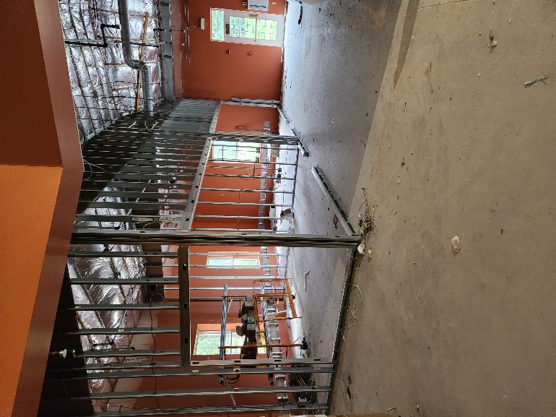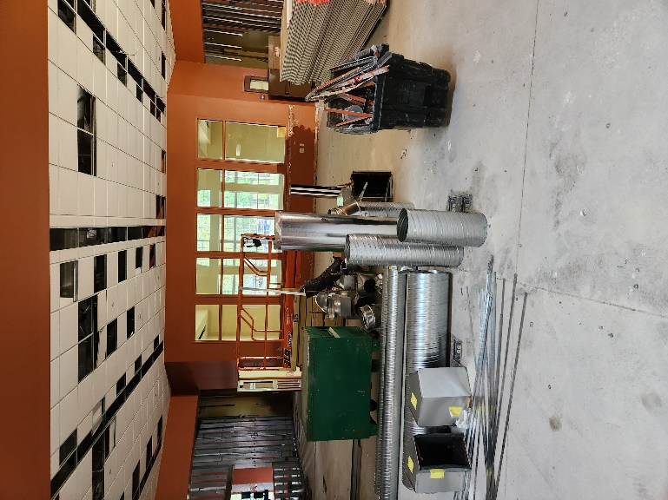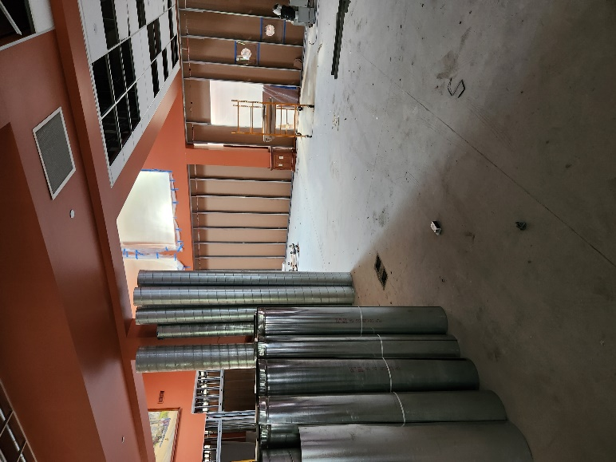

As always, please contact the Branch Manager or Assistant Branch Manager with any questions or concerns.
Thank you for your patience through this renovation process!

###

