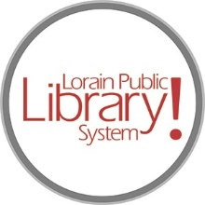
For more information, contact:
Jennifer Winkler, Branch Manager
JWinkler@lpls.info
or
Mark Peters, Assistant Branch Manager
MPeters@lpls.info
440-327-8326

LorainPublicLibrary.org

NORTH RIDGEVILLE PATRON UPDATE

November 14, 2023

Great news! The electrical supplies came in, the electrical rough-in was completed and approved by the city.

The welding of window frames to the interior meeting room doors will begin today. Once this is complete, they can start hanging drywall!

Meanwhile the old irrigation system is being replaced on the exterior of the building. This should be the last of the exterior work other than the new roof.

As always, please contact the Branch Manager or Assistant Branch Manager with any questions or concerns.
Thank you for your patience through this renovation process!





