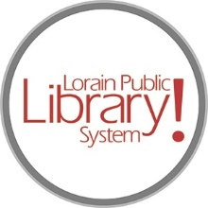

*For more information, contact:*

Anne Godec, Branch Manager

[AGodec@lpls.info](mailto:AGodec@lpls.info)

or

Mark Peters, Assistant Branch Manager

[MPeters@lpls.info](mailto:MPeters@lpls.info)

440-327-8326

[LorainPublicLibrary.org](http://www.lorainpubliclibrary.org/)

**NORTH RIDGEVILLE PATRON UPDATE**

May 7, 2024  
  
The electrical trench was filled in and once the concrete dried the new flooring was able to go down throughout the rest of the main areas.

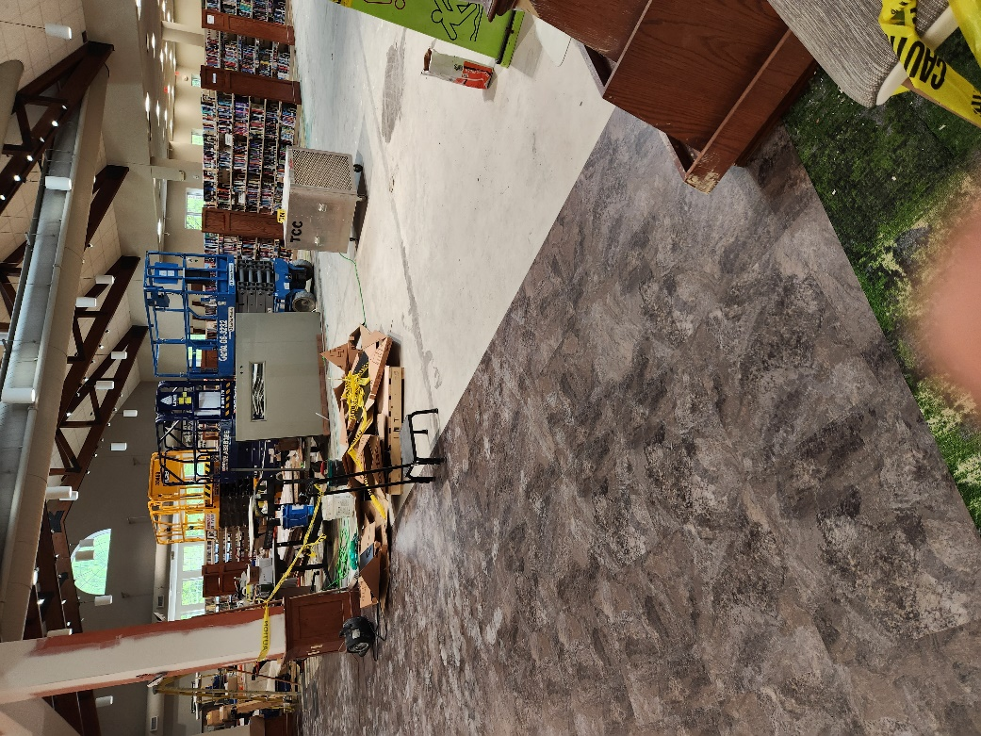 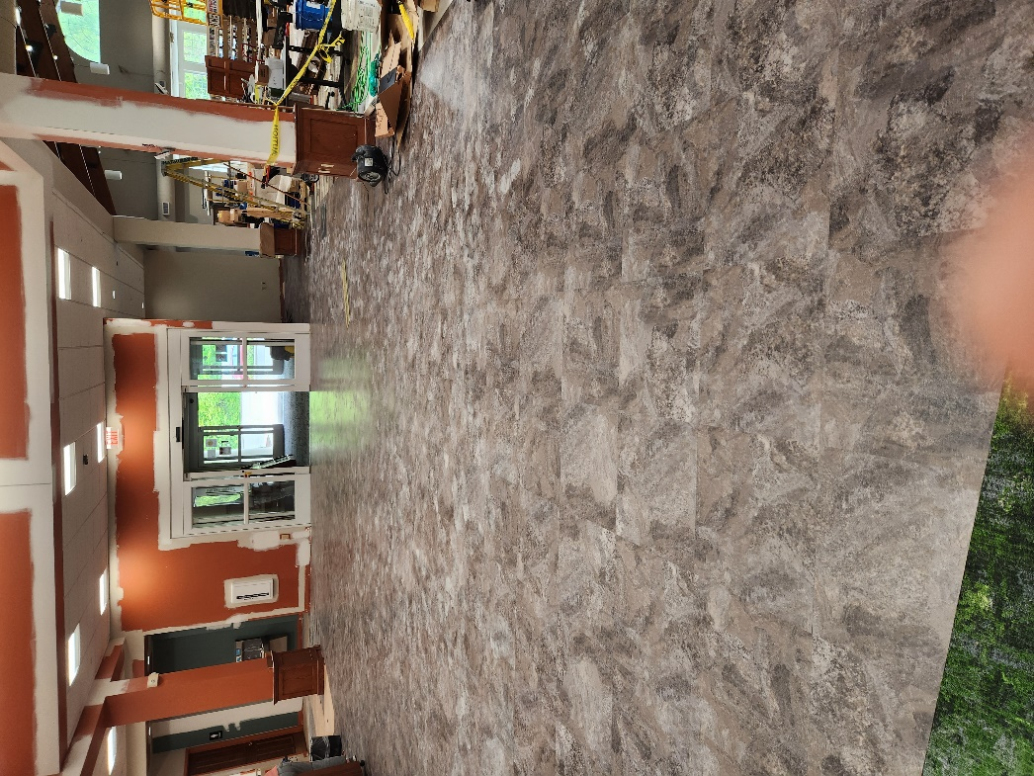

The new circulation desk is being built and will be installed in the coming weeks!

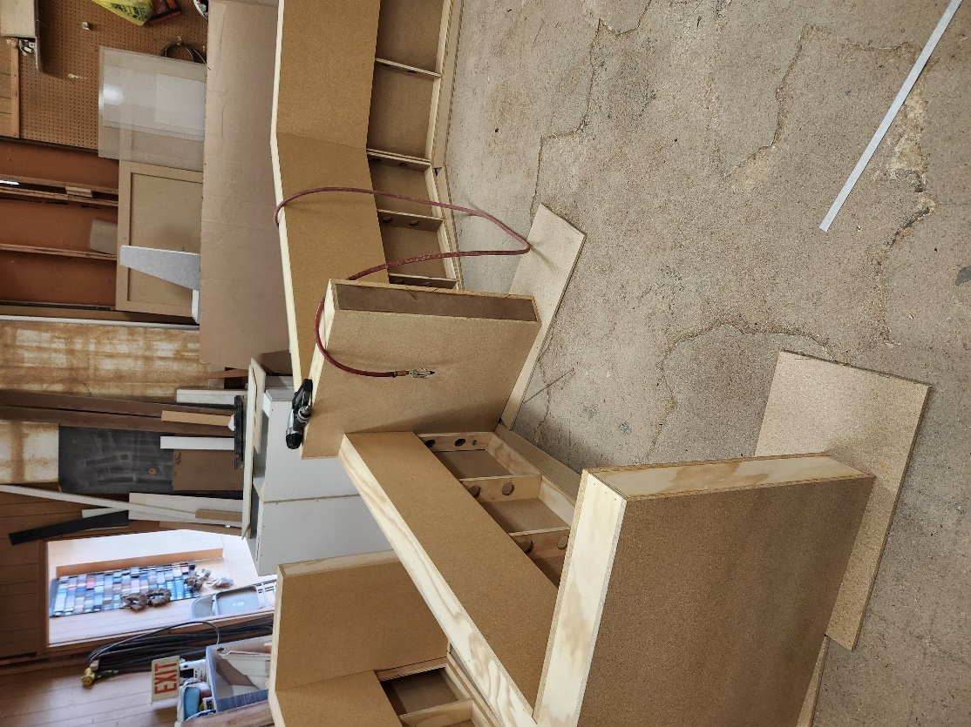 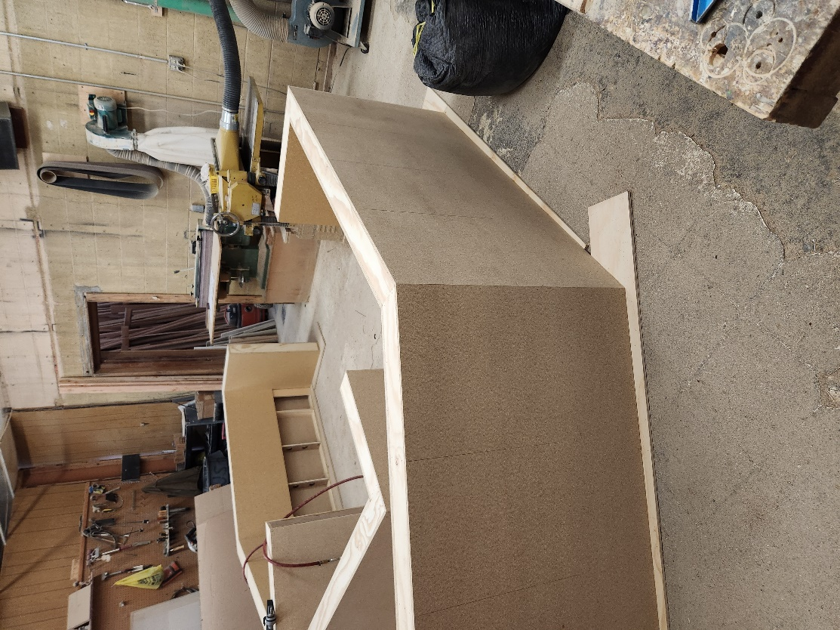

The remainder of the books have been brought in from the storage pods, so the pods will be removed from the parking lot soon. The temporary construction fencing came down this week as well.

Programming has resumed and story times are in full swing. Summer program registrations will open May 15 for all programs except those in the Create Space. Registrations for the Create Space programs at the North Ridgeville Branch will open June 15.

We are happy to announce that the North Ridgeville Branch will be the kickoff location for the Chamber’s annual Discover the Ridge event on Saturday, May 18! We have a carnival-theme event planned including games, Spring Mist Farms petting zoo and Twister Girl Balloon Company!

We are so very appreciative of your continued support! As always, please contact the Branch Manager or Assistant Branch Manager with any questions or concerns. Thank you for your patience through this process!

###