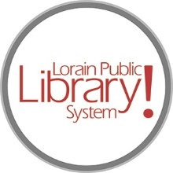

*For more information, contact:*

Anne Godec, Branch Manager

[AGodec@lpls.info](mailto:AGodec@lpls.info)

or

Mark Peters, Assistant Branch Manager

[MPeters@lpls.info](mailto:MPeters@lpls.info)

440-327-8326

[LorainPublicLibrary.org](http://www.lorainpubliclibrary.org/)

**NORTH RIDGEVILLE PATRON UPDATE**

May 14, 2024

The first pieces of the new circulation desk are here! The rest of the desk should be here on Thursday.

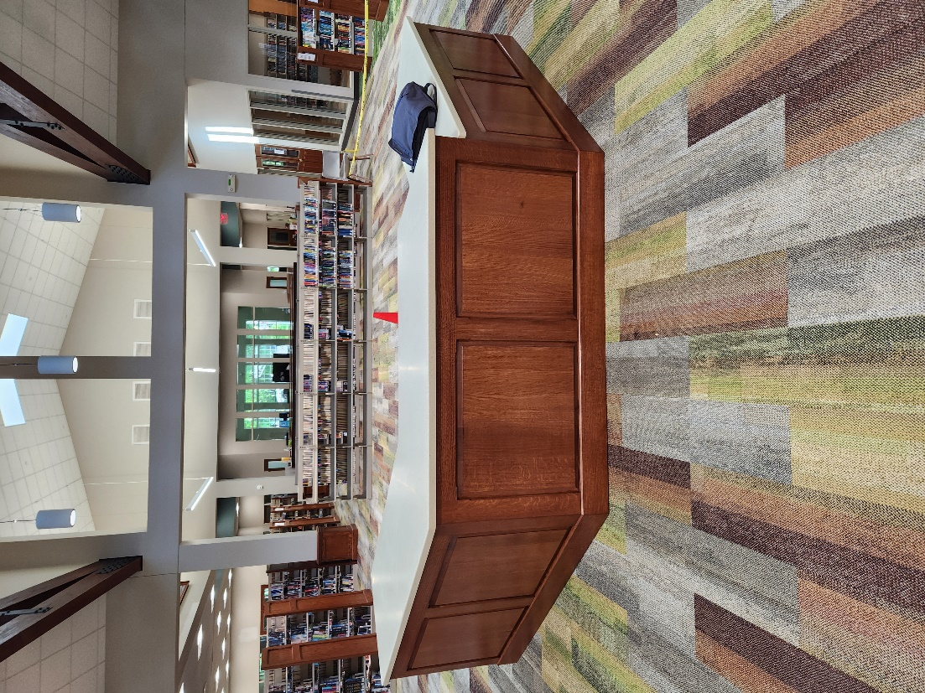 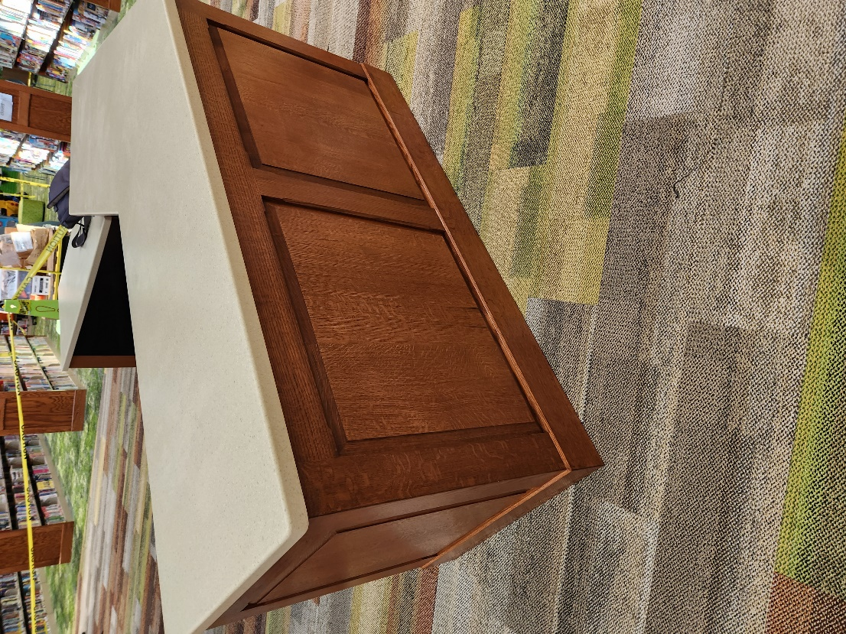

We are still working our way through the boxes of books that had been in storage to get them back on the shelves.

Don’t forget, summer program registrations open May 15 for all programs except those in the Create Space! Registrations for the Create Space programs at the North Ridgeville Branch will open June 15.

The North Ridgeville Branch is the kickoff location for the Chamber’s annual Discover the Ridge event on Saturday, May 18. We have a carnival-theme event planned including games, Spring Mist Farms petting zoo (weather permitting) and Twister Girl Balloon Company.

We are so very appreciative of your continued support! As always, please contact the Branch Manager or Assistant Branch Manager with any questions or concerns. Thank you for your patience through this process!

###