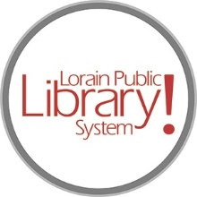
For more information, contact:
Jennifer Winkler, Branch Manager
JWinkler@lpls.info
or
Mark Peters, Assistant Branch Manager
MPeters@lpls.info
440-327-8326

LorainPublicLibrary.org

NORTH RIDGEVILLE PATRON UPDATE

March 26, 2024
The temporary wall should be coming down later this week to reveal the new and improved Children’s Area.
There is still some work to be done in this area but it is minor. Here is a sneak peek as to what the crew was doing behind the wall:
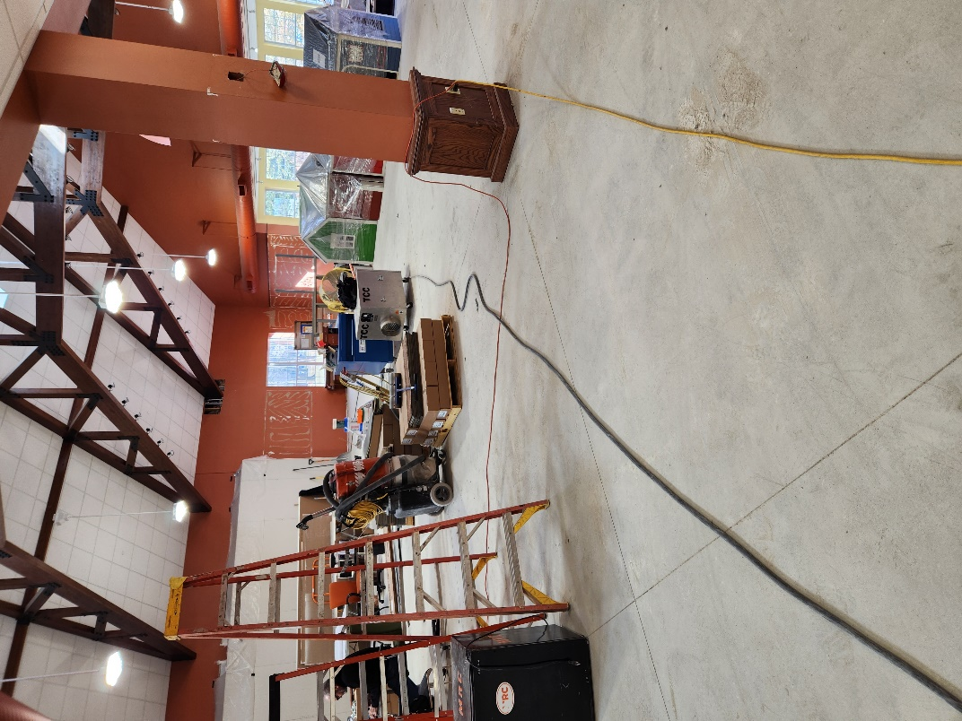 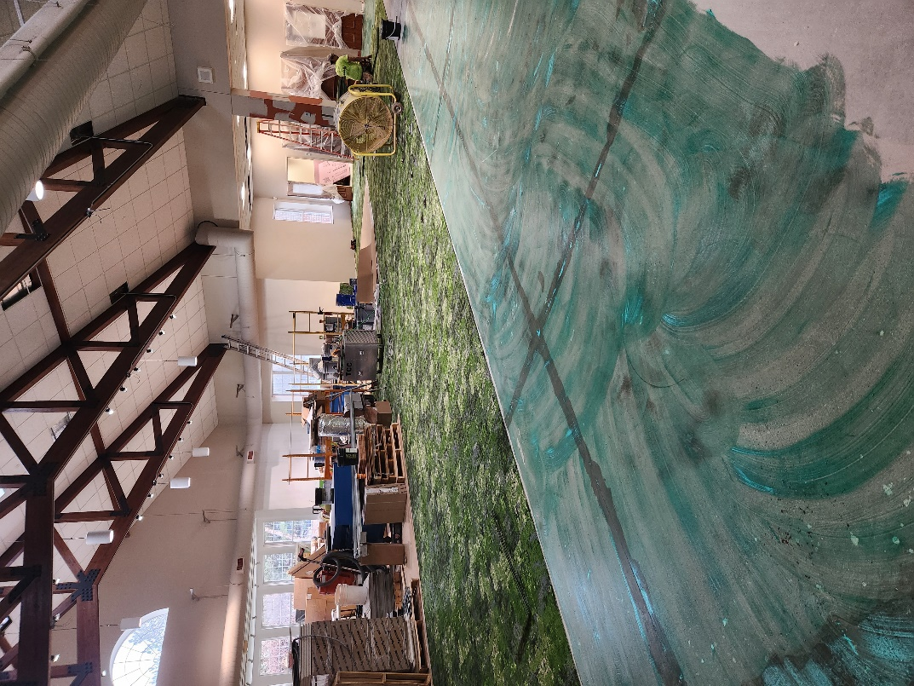

The carpet was removed and the walls were patched The area got a fresh coat of paint, new carpet and new
lighting

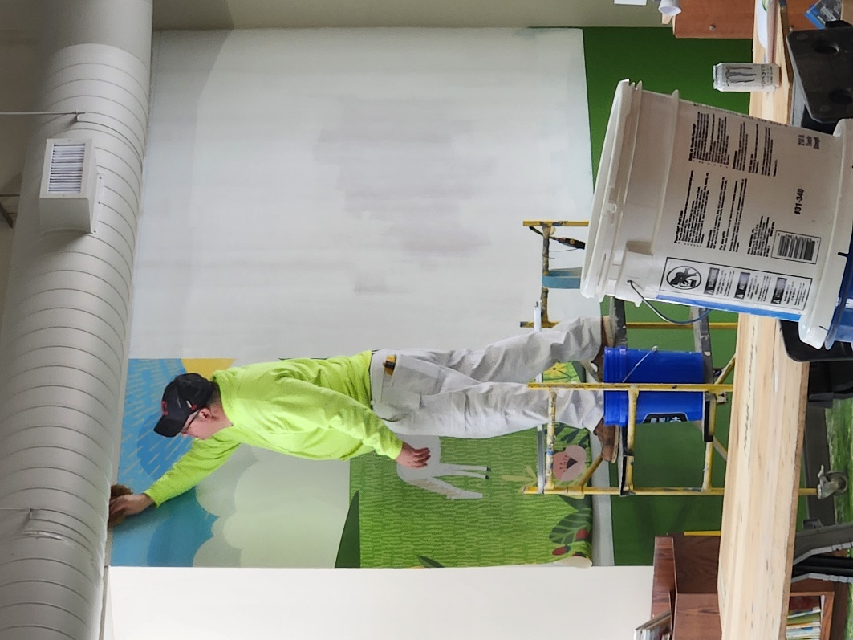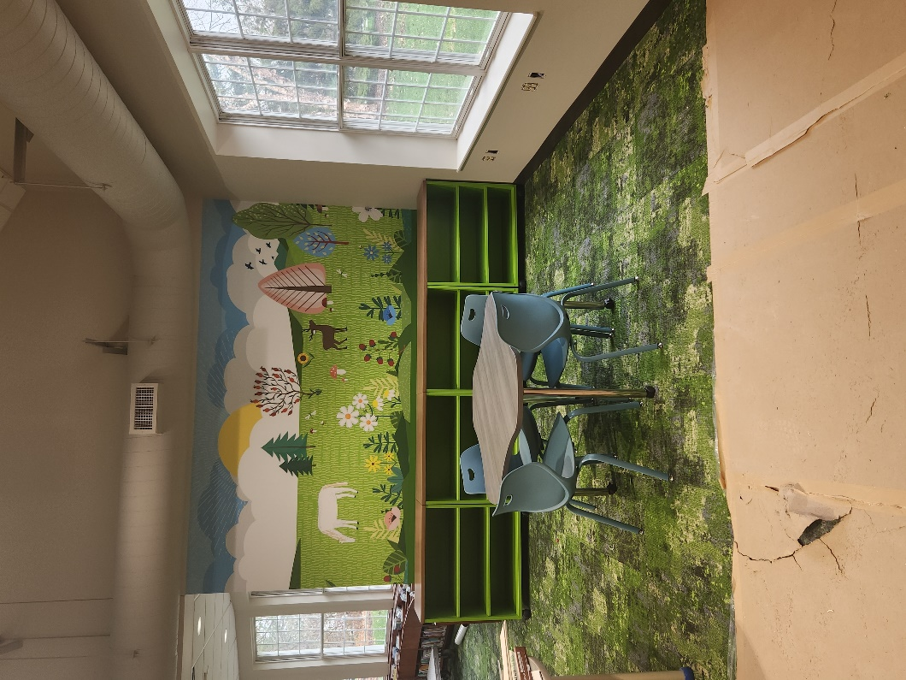

Fun new murals were installed …and some new furniture

Please bear with us as the most difficult part of the renovation is yet to come.

We need to remove the current circulation desk, remove the carpet from the central area of the building and replace it as well as paint the central area, replace the lighting and bring in a large new service desk --- all while staying open so we can continue to serve the community.
We are so very appreciative of your continued support!
As always, please contact the Branch Manager or Assistant Branch Manager with any questions or concerns.
Thank you for your patience through this process!

###

