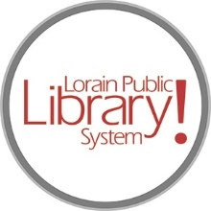
For more information, contact:
Jennifer Winkler, Branch Manager
JWinkler@lpls.info
or
Mark Peters, Assistant Branch Manager
MPeters@lpls.info
440-327-8326

LorainPublicLibrary.org

NORTH RIDGEVILLE PATRON UPDATE

March 12, 2024
Furniture is being placed in Phase one! Here is a sneak peek of the Teen Zone:

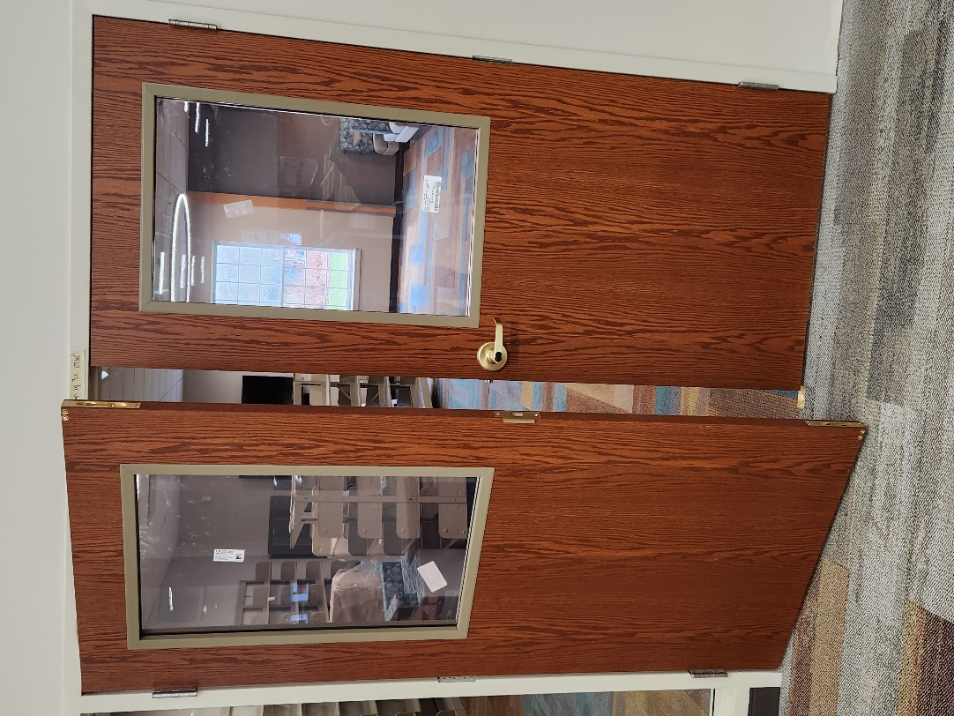

New doors are in YA collection on the shelves, new lighting

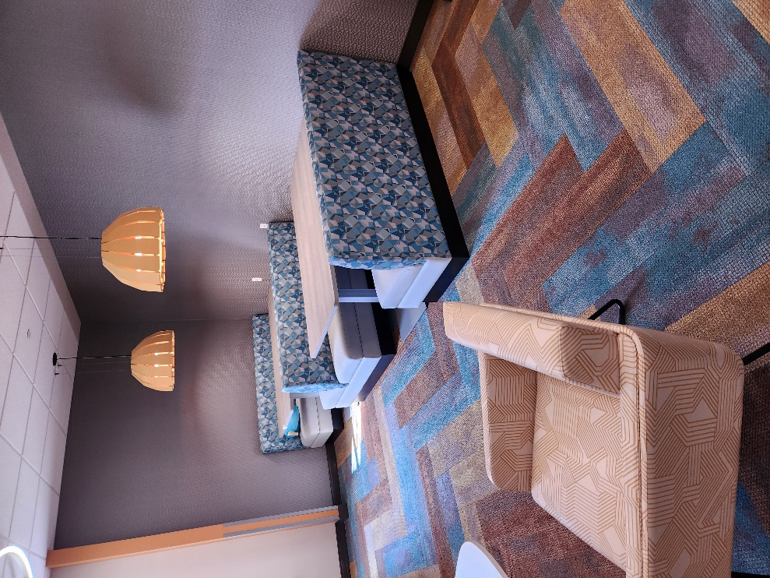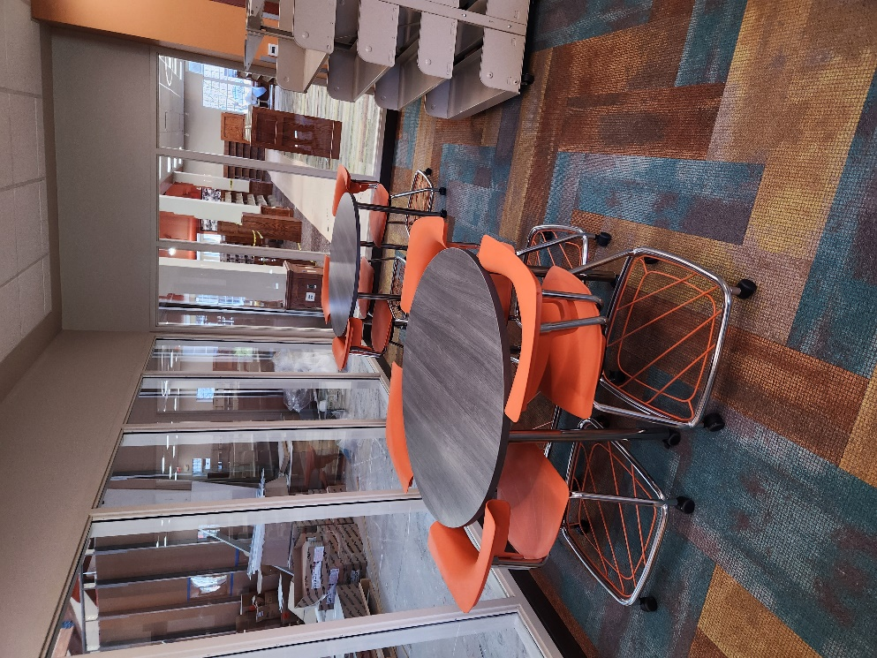

Multiple seating areas to gather and study together

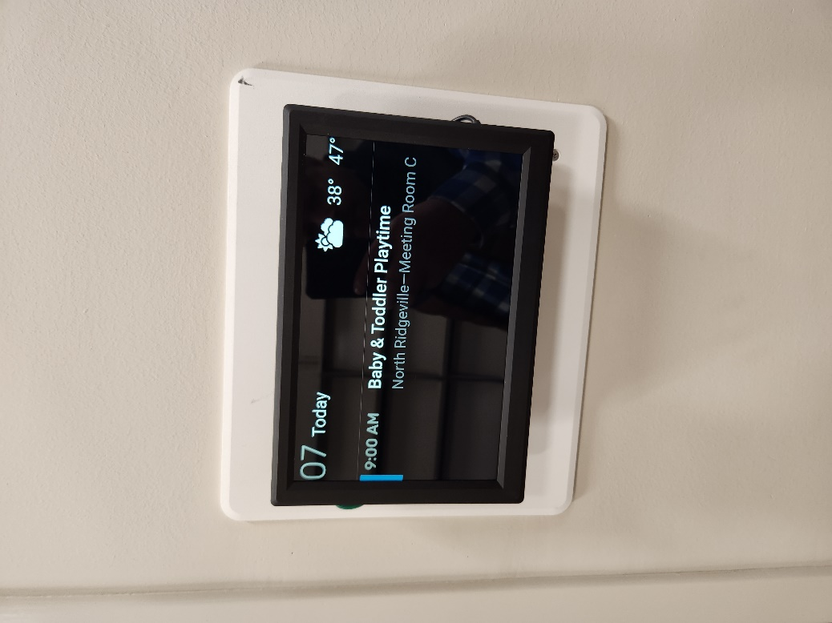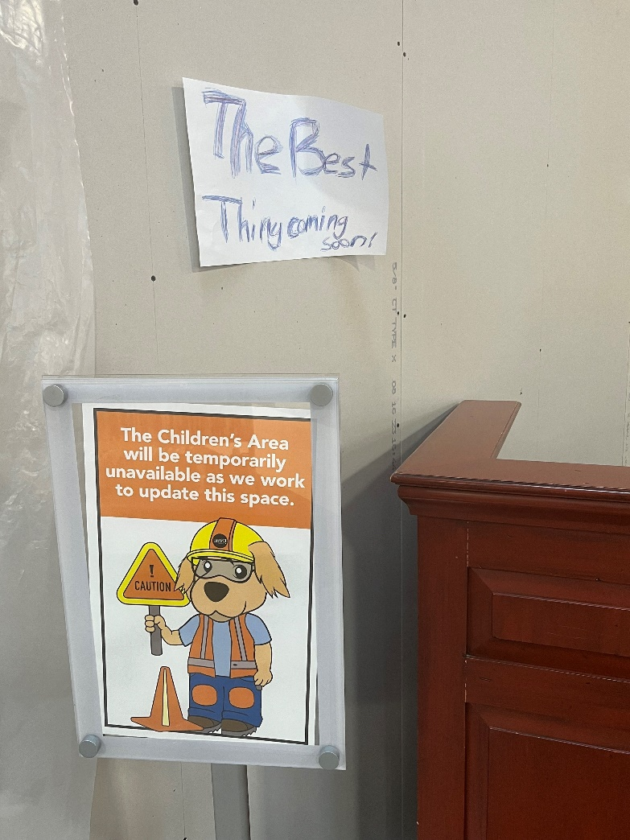
Ther are now cool monitors outside each meeting We think this little patron’s sign says it all as far
room to let you know which program is where as Phase 2 goes!
As always, please contact the Branch Manager or Assistant Branch Manager with any questions or concerns.
Thank you for your patience through this process!

###

