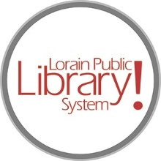
For more information, contact:
Jennifer Winkler, Branch Manager
JWinkler@lpls.info
or
Mark Peters, Assistant Branch Manager
MPeters@lpls.info
440-327-8326

LorainPublicLibrary.org

NORTH RIDGEVILLE PATRON UPDATE

January 30, 2024

The temporary construction wall has been moved from the south end of the building to now temporarily close off the Children’s Area as the refresh continues in that portion of the building.

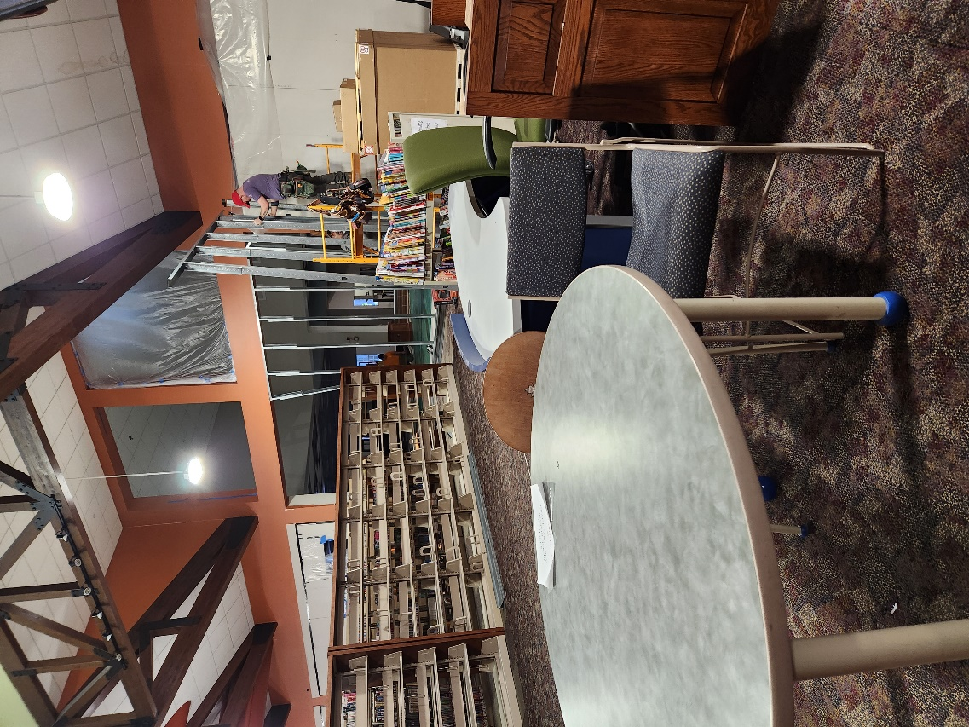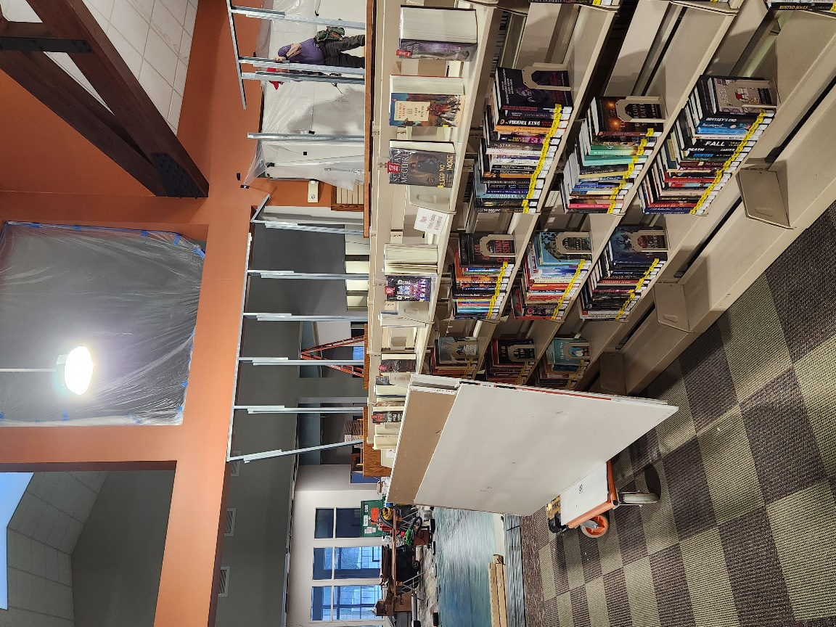

The majority of the Children’s Area items are safely tucked away in a meeting room for now.

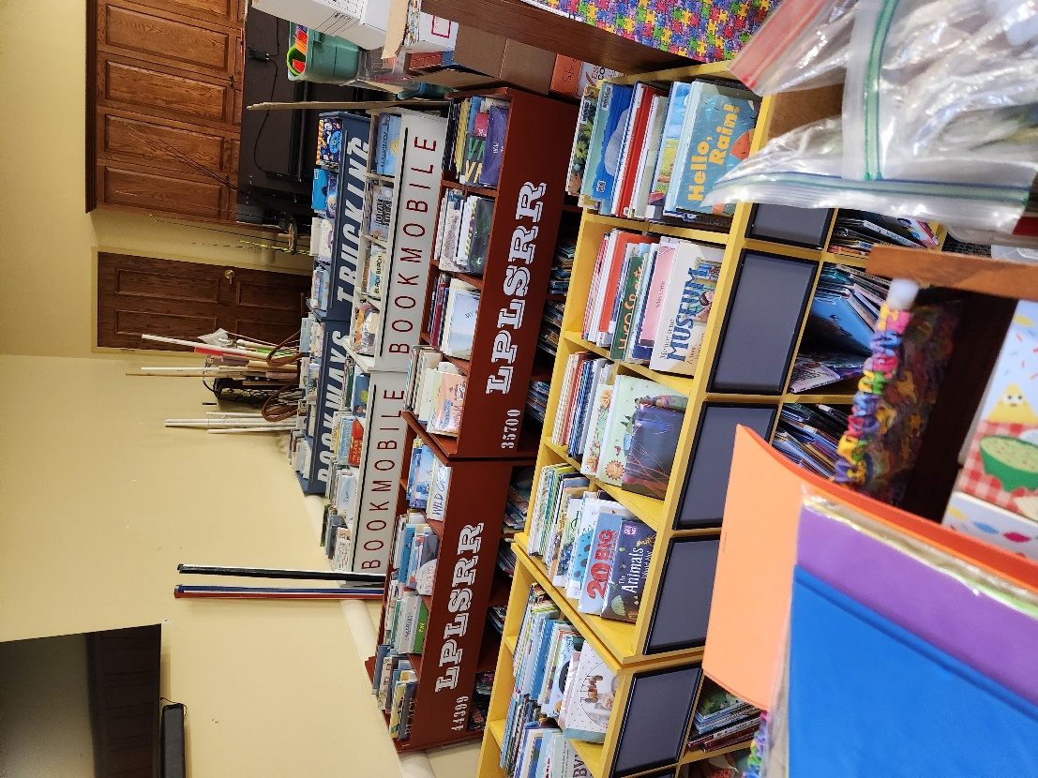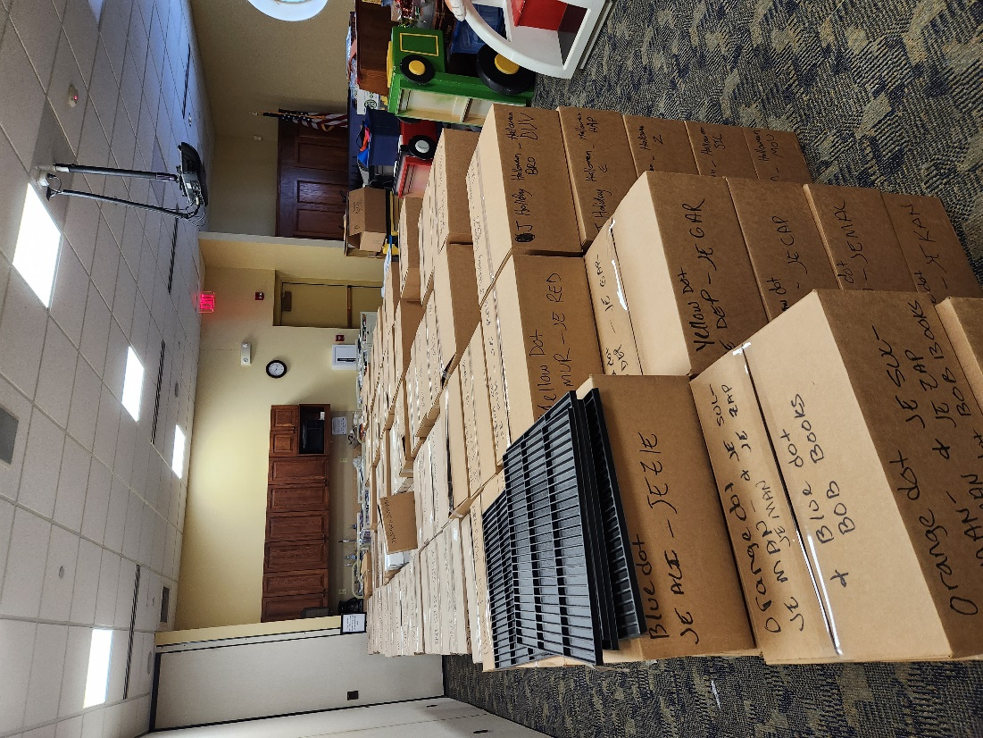

The new shelving units have arrived and are being assembled! New furniture is due to arrive next week.

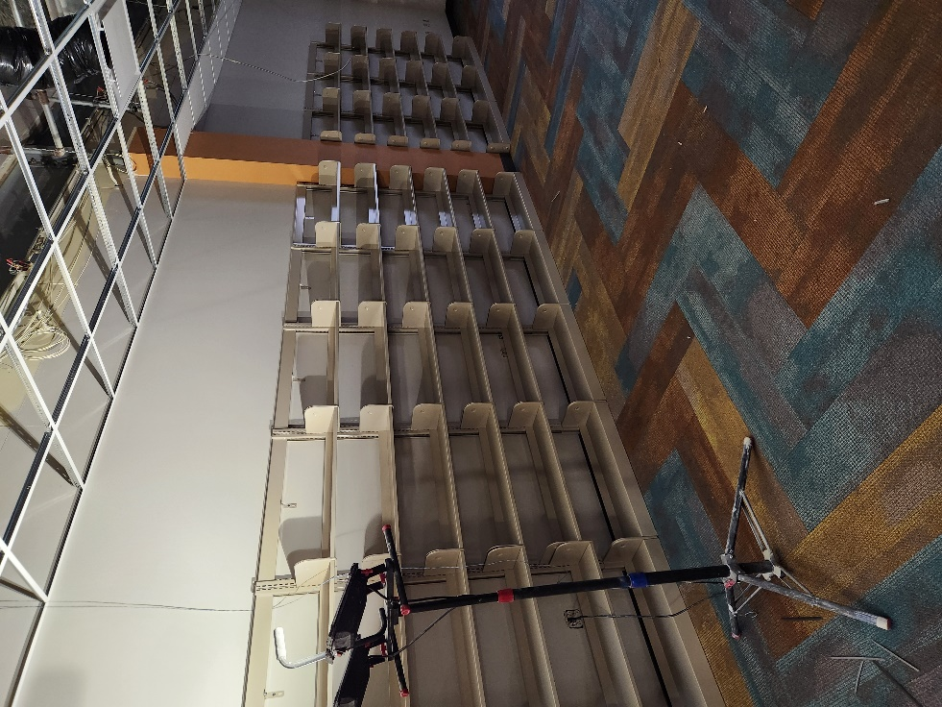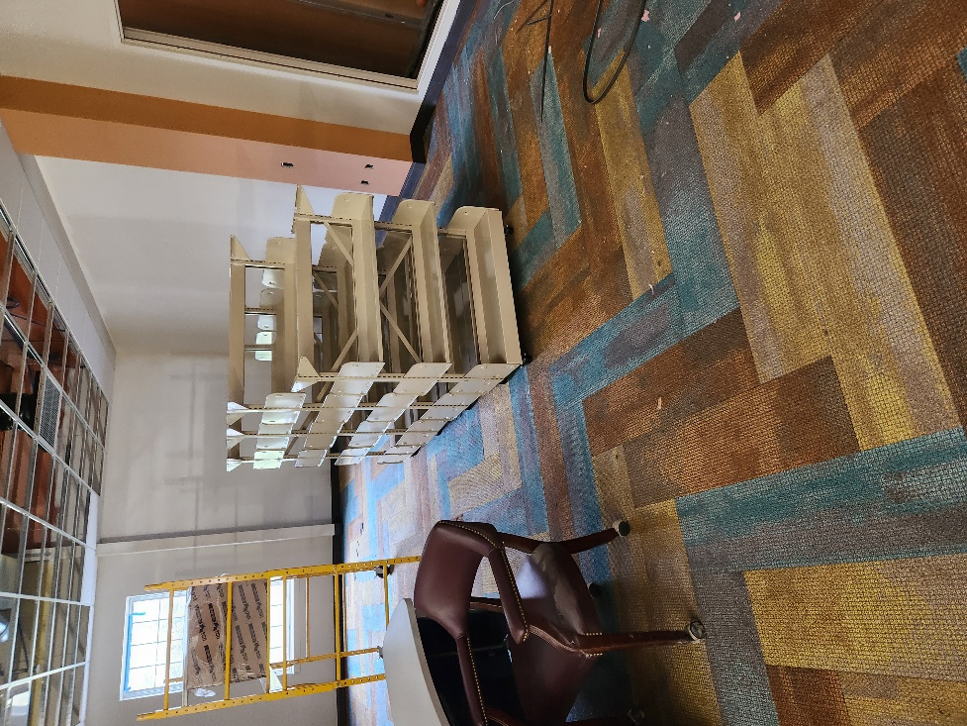

The North Ridgeville Branch has a levy on the ballot in March. This levy is a renewal and will not raise taxes. It is the same levy that is on the ballot every five years; the ask has not changed in the past fifteen years.

The funds from the levy are 85% of the branch’s operating revenue which includes maintenance and upkeep of the building and grounds.

It is funds from past levies that are paying for the renovations you see here, and for the recent replacement of the 20-year-old roof.
As always, please contact the Branch Manager or Assistant Branch Manager with any questions or concerns.
Thank you for your patience through this renovation process!

###

