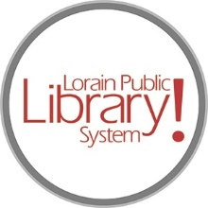
For more information, contact:
Jennifer Winkler, Branch Manager
JWinkler@lpls.info
or
Mark Peters, Assistant Branch Manager
MPeters@lpls.info
440-327-8326

LorainPublicLibrary.org

NORTH RIDGEVILLE PATRON UPDATE

January 23, 2024

The carpet is being laid in the main open area, meeting rooms and quiet reading room. This is the end of the construction portion of Phase 1. When Phase 2 begins, it will be necessary to temporarily close off the Children’s Area. Signs will be posted.

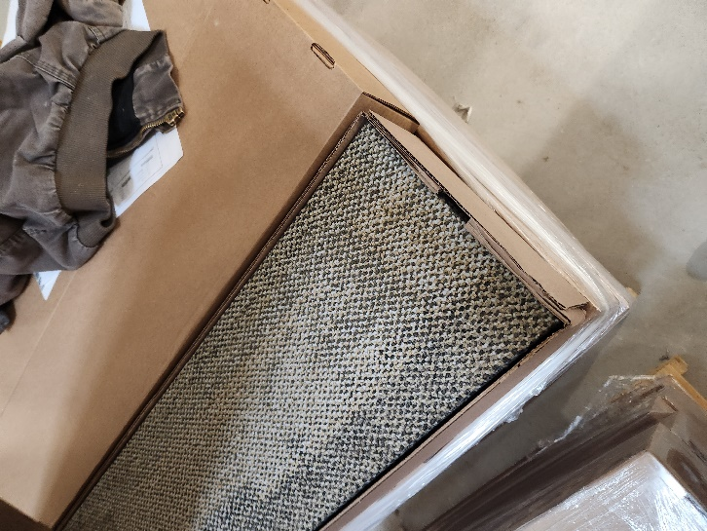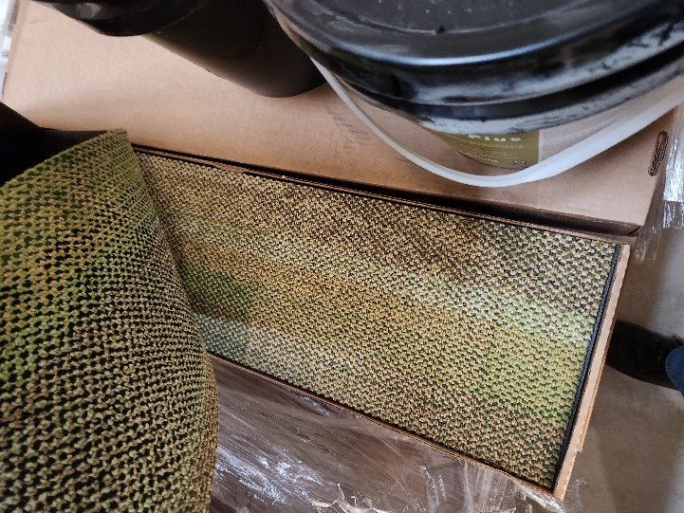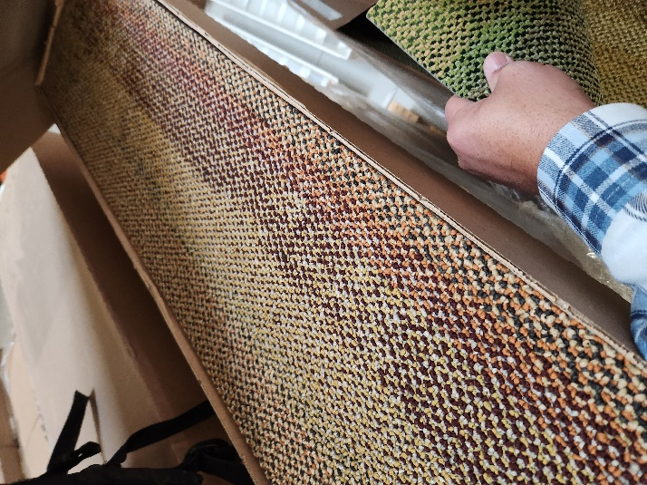

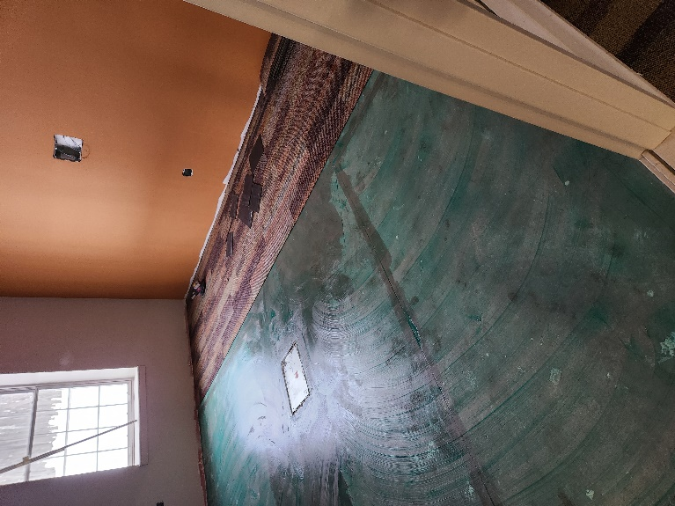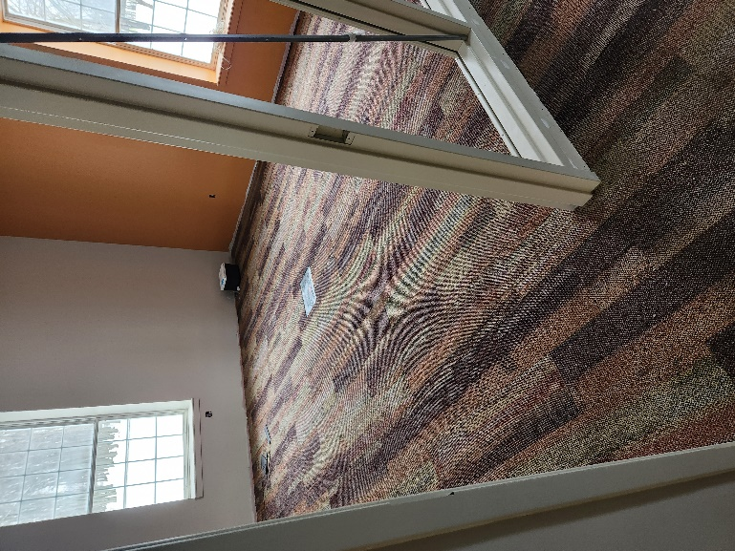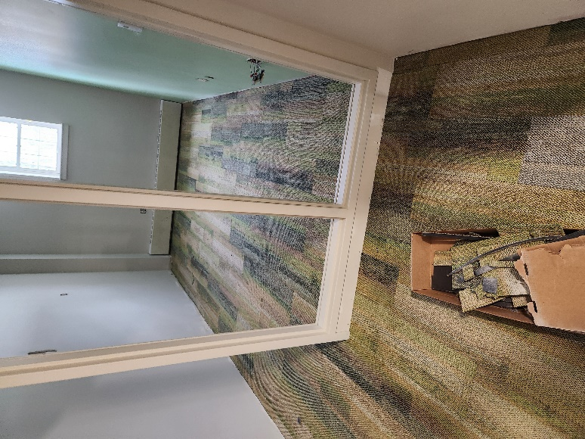

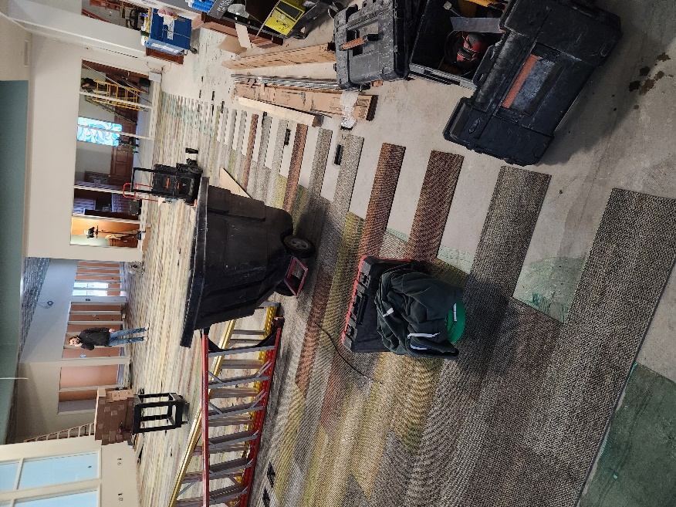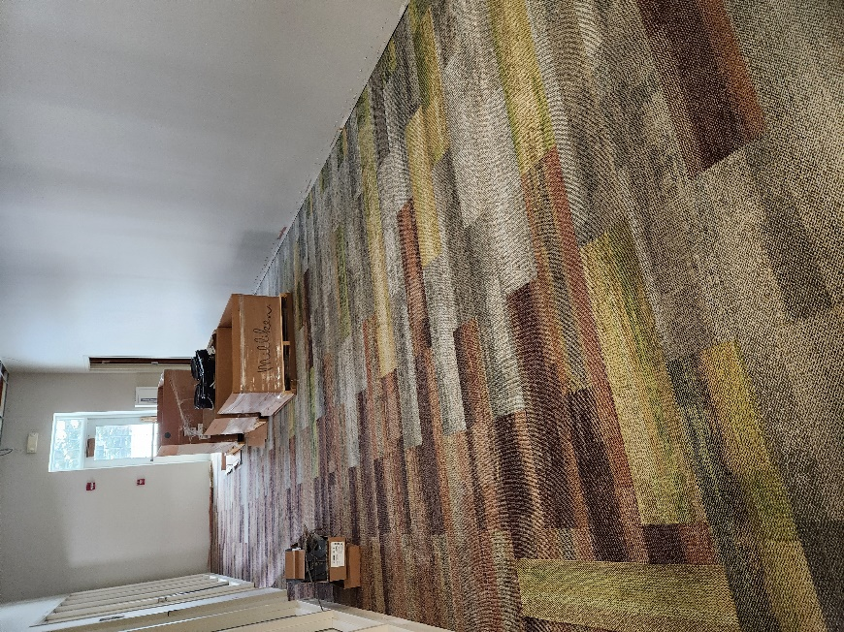

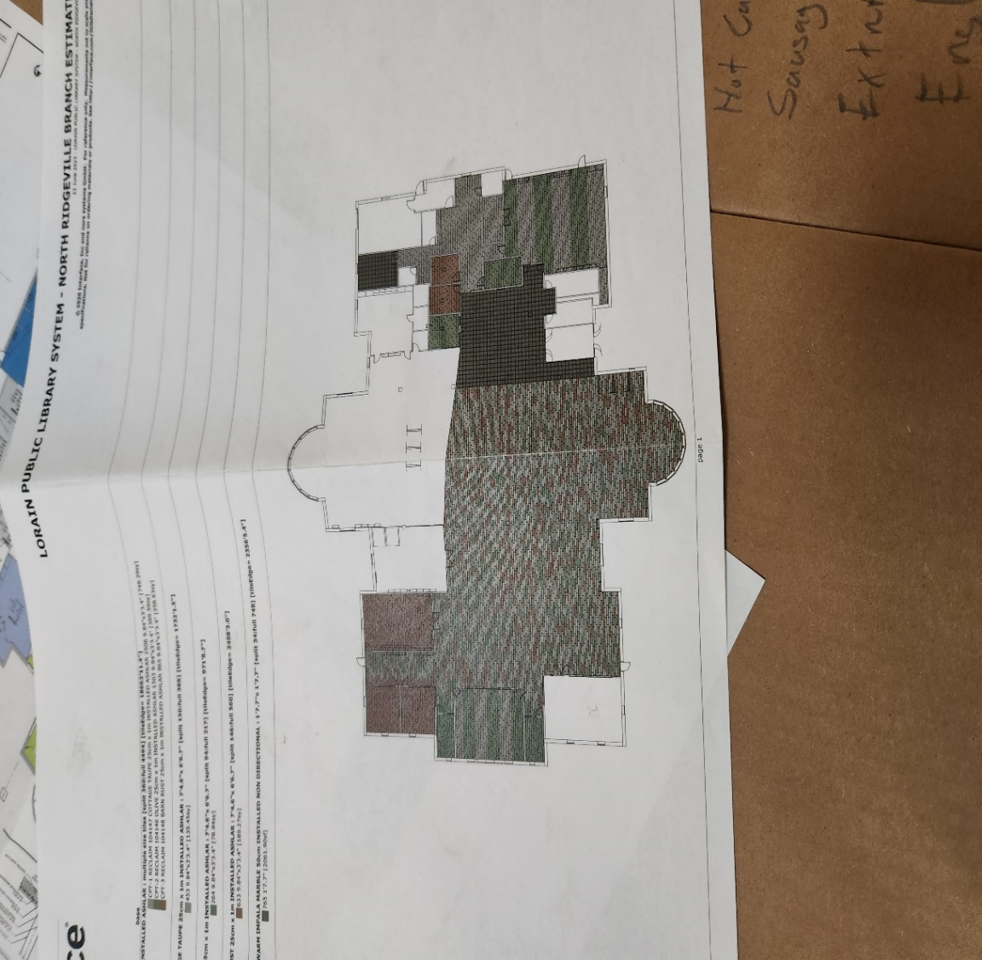

As always, please contact the Branch Manager or Assistant Branch Manager with any questions or concerns.
Thank you for your patience through this renovation process!
###

