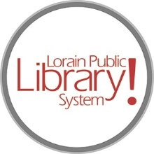
For more information, contact:
Jennifer Winkler, Branch Manager
JWinkler@lpls.info
or
Mark Peters, Assistant Branch Manager
MPeters@lpls.info
440-327-8326

LorainPublicLibrary.org

NORTH RIDGEVILLE PATRON UPDATE

January 16, 2024

The drywall is done and painting is underway. Things will start happening quickly as ceiling tiles will go in, the carpet will get laid and the new book shelves will be delivered; all slated to happen before the end of this month.
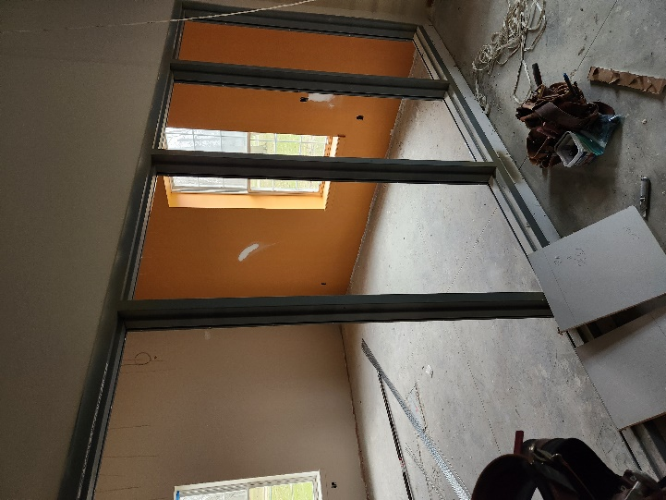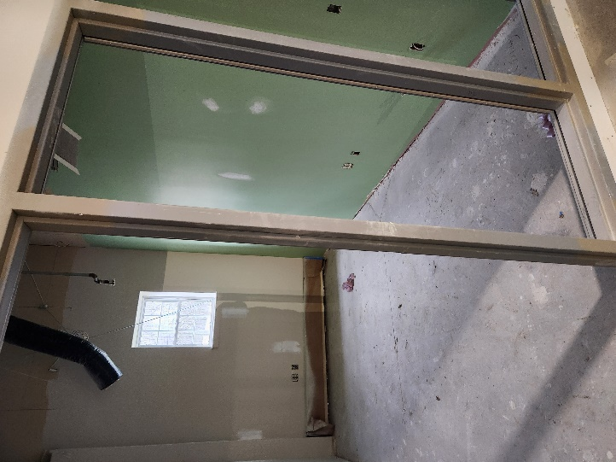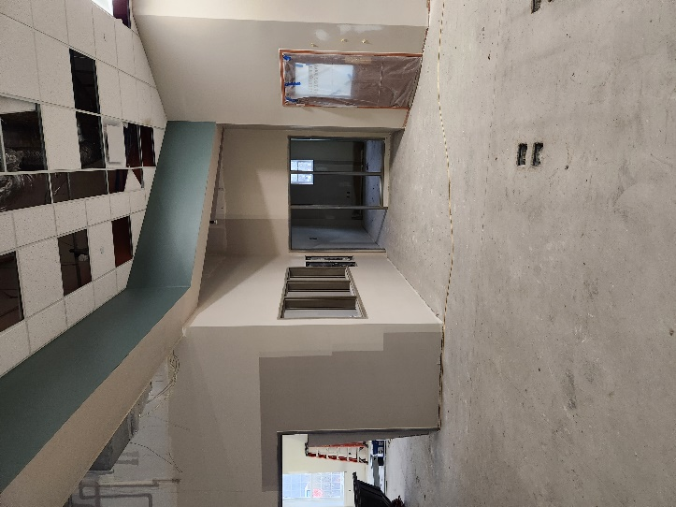

The temporary construction wall will come down when Phase One is complete. When the crew begins Phase Two, it will be necessary to temporarily close off the Children’s Area. Signs will be posted.
As always, please contact the Branch Manager or Assistant Branch Manager with any questions or concerns.
Thank you for your patience through this renovation process!

###

