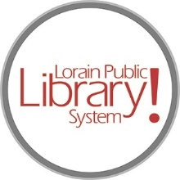
For more information, contact:
Jennifer Winkler, Branch Manager
JWinkler@lpls.info
or
Mark Peters, Assistant Branch Manager
MPeters@lpls.info
440-327-8326

LorainPublicLibrary.org

NORTH RIDGEVILLE PATRON UPDATE

February 27, 2024
Phase Two continues with the new Passport Services room being framed and the staff areas getting a refresh with new paint and flooring.
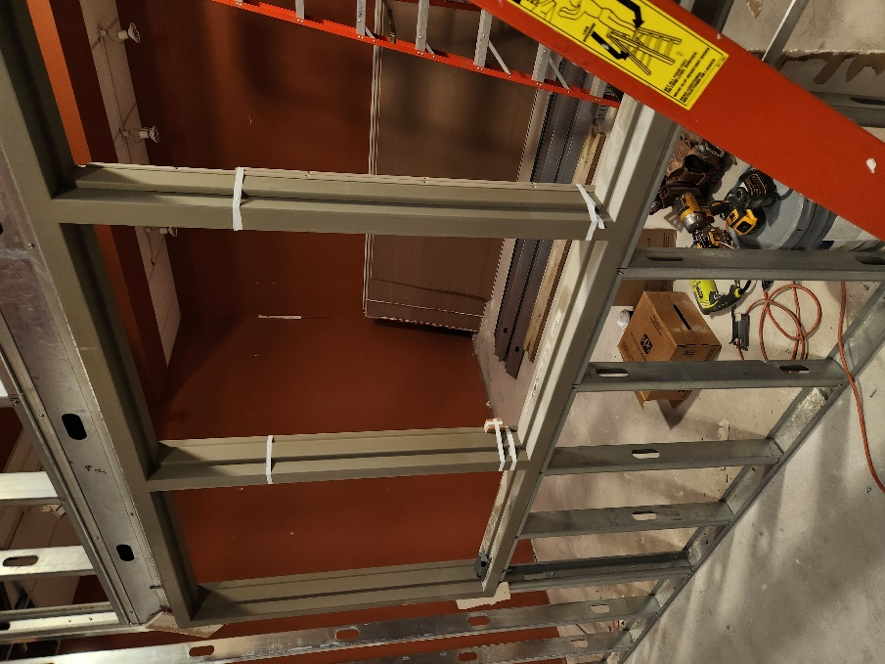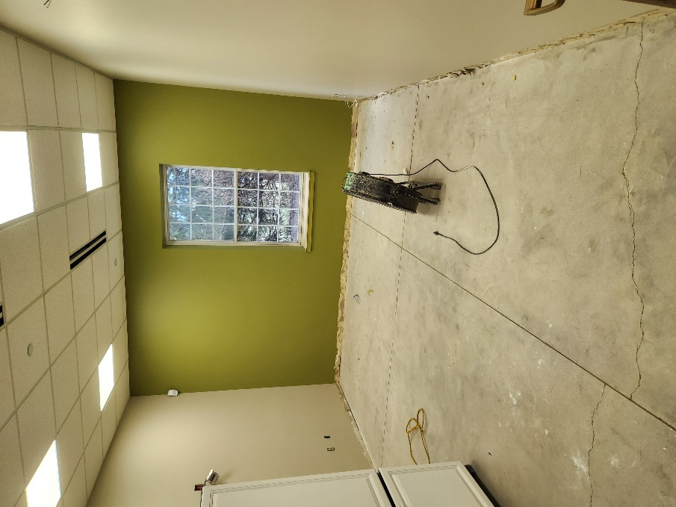
New Passport Services Room Staff breakroom refresh

We’re almost ready to start “the great book move!” We will be moving the books that are on the shelves in the adult section over to the new empty shelves in the south end of the building. Once that is done, the current shelves can be moved to allow for the new carpet to be placed.

After the carpet is in, the shelves will be put back in place and the books will be moved back to their original places. Then the books that have been hibernating in pods will be brought back into the building to fill the new shelves in the south end.
As always, please contact the Branch Manager or Assistant Branch Manager with any questions or concerns.
Thank you for your patience through this process!

###

