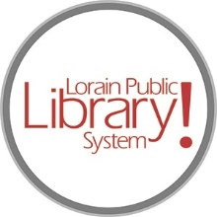
For more information, contact:
Jennifer Winkler, Branch Manager
JWinkler@lpls.info
or
Mark Peters, Assistant Branch Manager
MPeters@lpls.info
440-327-8326

LorainPublicLibrary.org

NORTH RIDGEVILLE PATRON UPDATE

February 20, 2024
Phase One (the south end of the building) is mostly complete, with just punch-list items left such as paint touch-up and faceplates. The IT Department has been called in to get the monitors up and running in the meeting rooms and install the new Meeting Owls, which are 360-degree video conference cameras with audio to provide an immersive meeting experience.

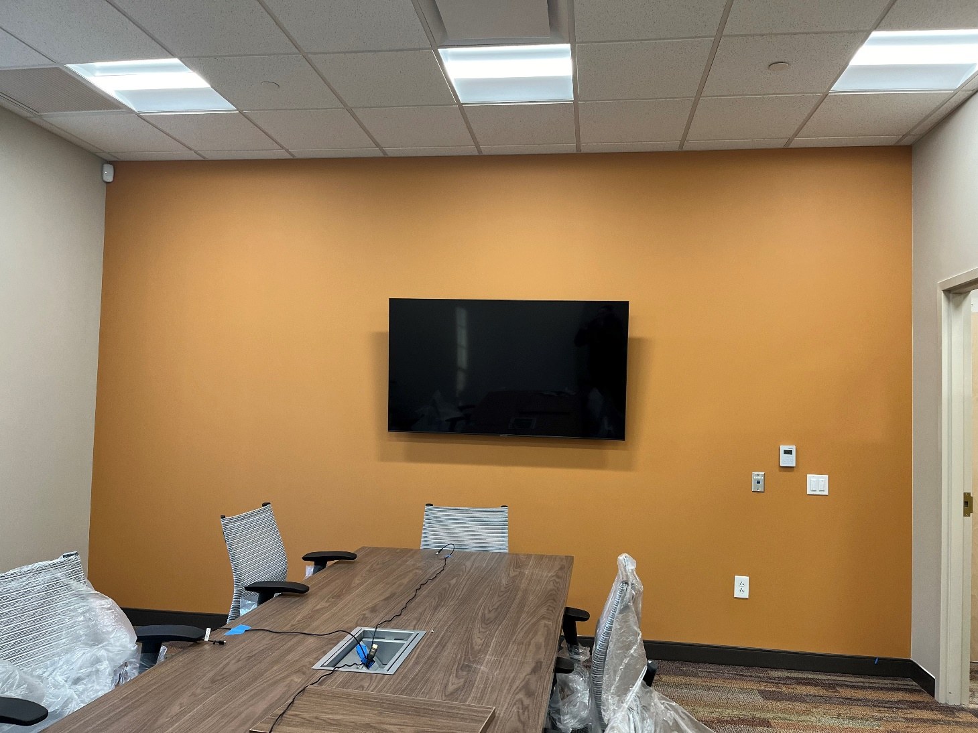

Create Space equipment is arriving:
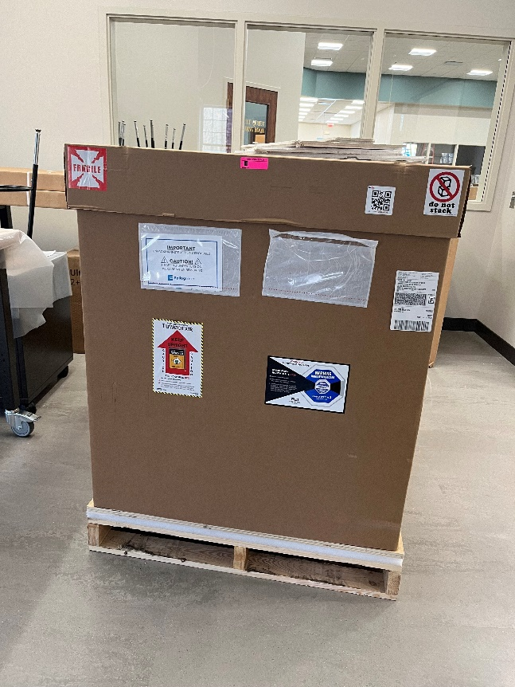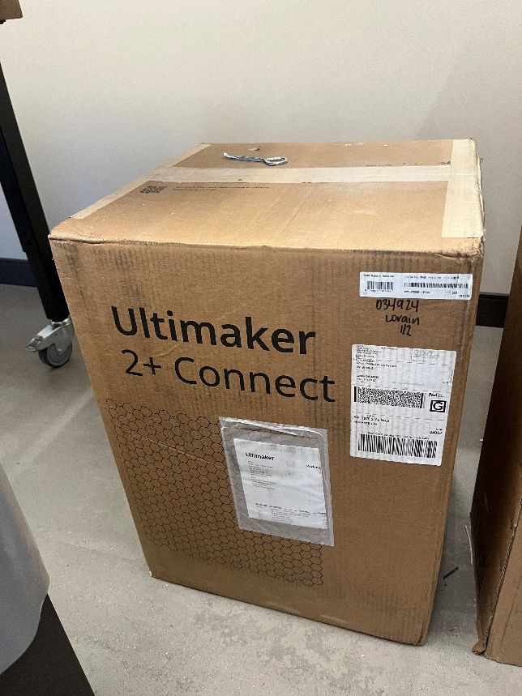

Phase Two is underway. The old carpet has been removed and the painting has begun:

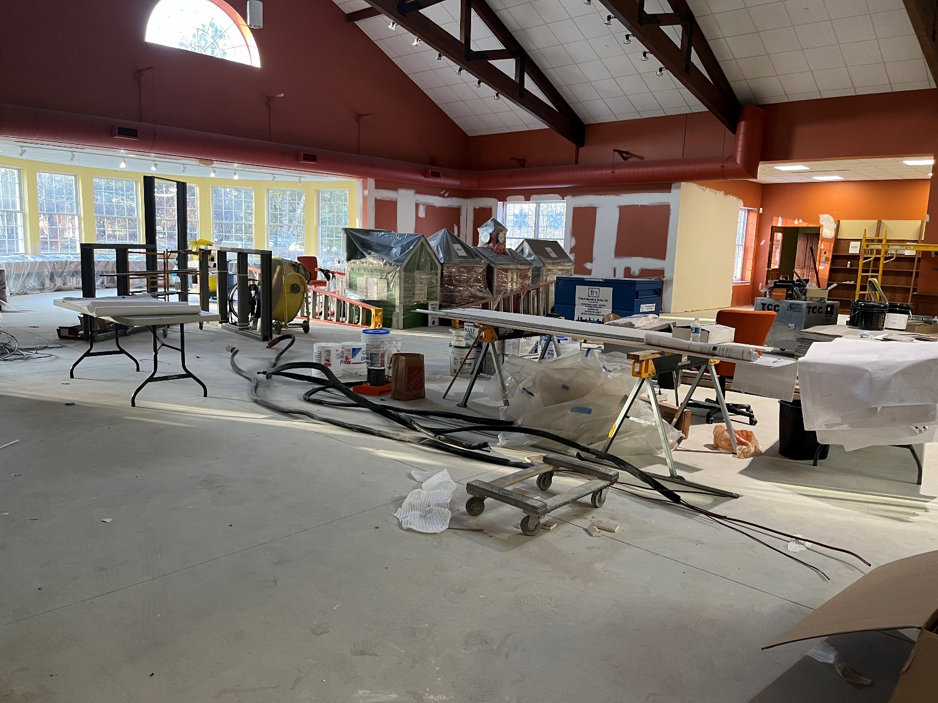

The North Ridgeville Branch has a levy, Issue 8, on the ballot in March. This levy is a renewal and will not raise taxes. It is the same levy that is on the ballot every five years; the ask has not changed in the past fifteen years.

The funds from the levy are 85% of the branch’s operating revenue which includes maintenance and upkeep of the building and grounds.

It is funds from past levies that are paying for the renovations you see here, and for the recent replacement of the 20-year-old roof. The funds were earmarked after the passage of the 2014 and 2019 levies but due to COVID-19 and supply chain issues, the project had been delayed.
As always, please contact the Branch Manager or Assistant Branch Manager with any questions or concerns.
Thank you for your patience through this process!

###

