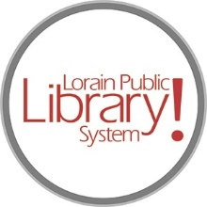
For more information, contact:
Jennifer Winkler, Branch Manager
JWinkler@lpls.info
or
Mark Peters, Assistant Branch Manager
MPeters@lpls.info
440-327-8326

LorainPublicLibrary.org

NORTH RIDGEVILLE PATRON UPDATE

February 7, 2024

The crew is making great progress in building and placing the new shelving units!

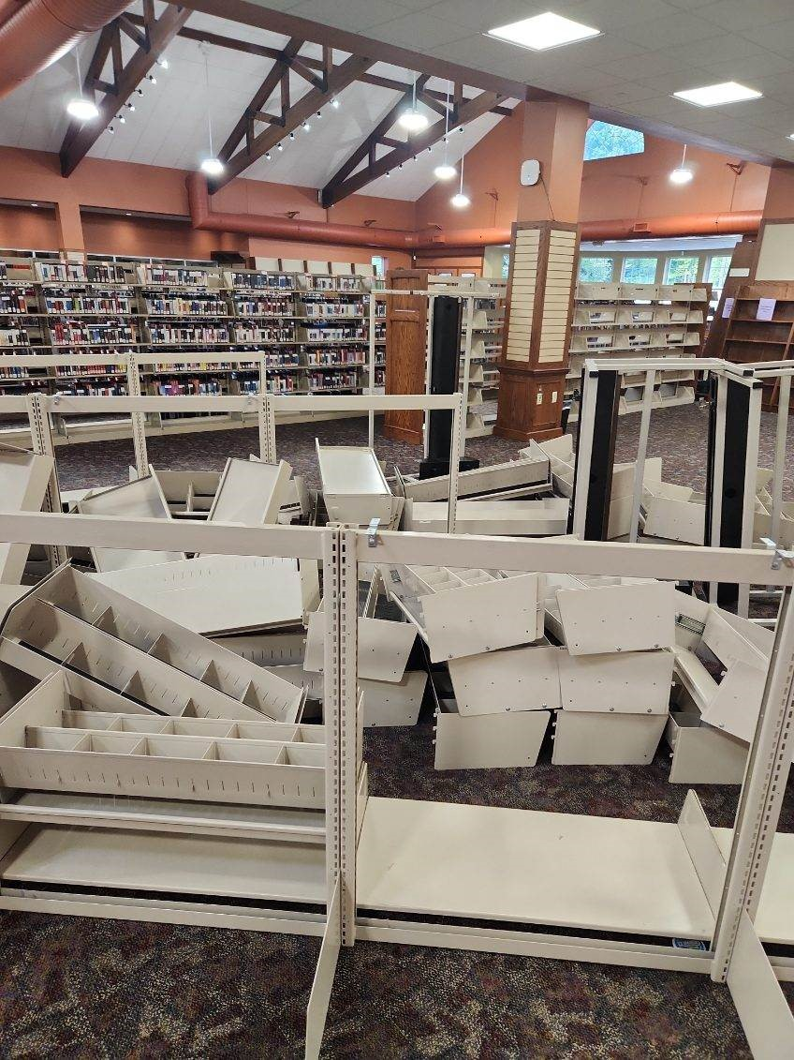 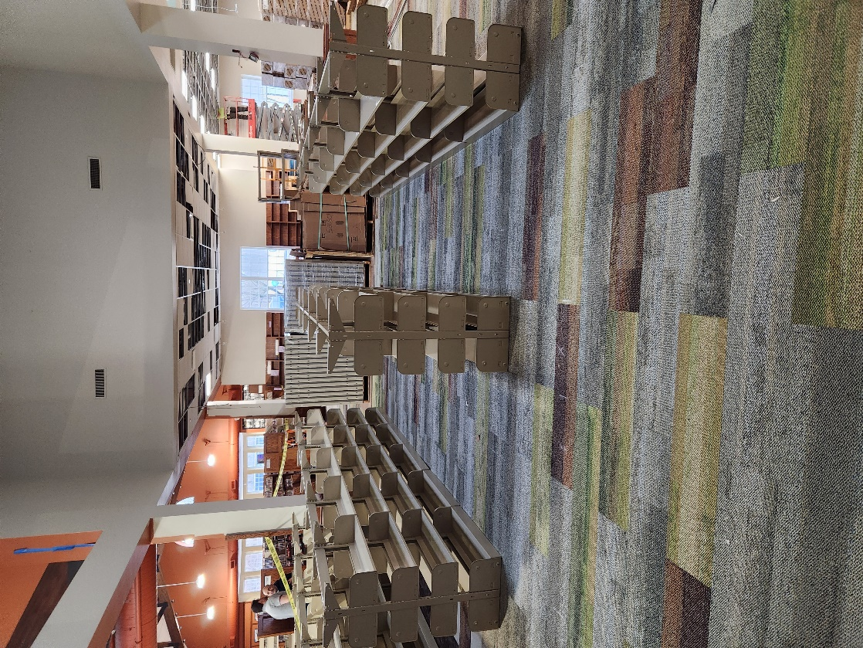
While we’re very excited to get books on these shelves, it will be a while yet. The carpet needs to be replaced in the main area of the building – the area that has been open to the public throughout the process. That will be the third and final phase of this overall refresh.

When that happens, all the books that have been available to circulate during this process will need to be removed from their current shelves and placed on these new shelves temporarily while the crew moves the current shelves, replaces the carpet and puts shelves back into place.
The books will then go back on to their original shelves, leaving these new shelves once again empty. Library staff can then happily bring the books from the storage untis back into the building and the North Ridgeville Branch refresh will be complete!

The new furniture has begun arriving as well! Here is a sneak peek:
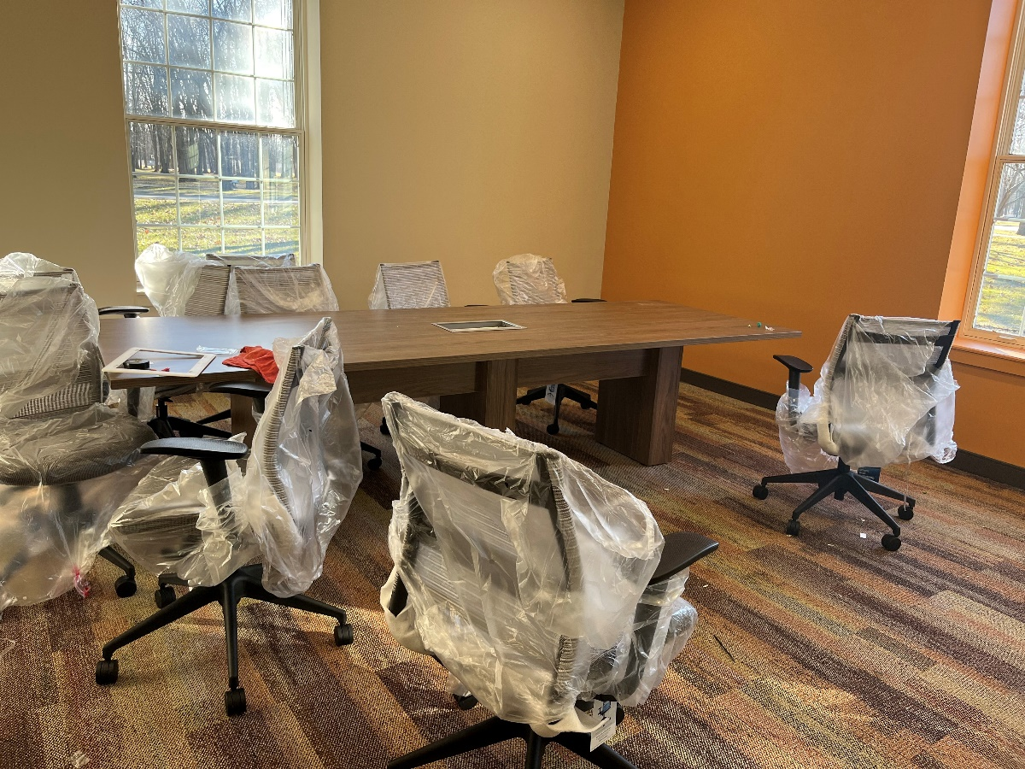
One of the new meeting room spaces
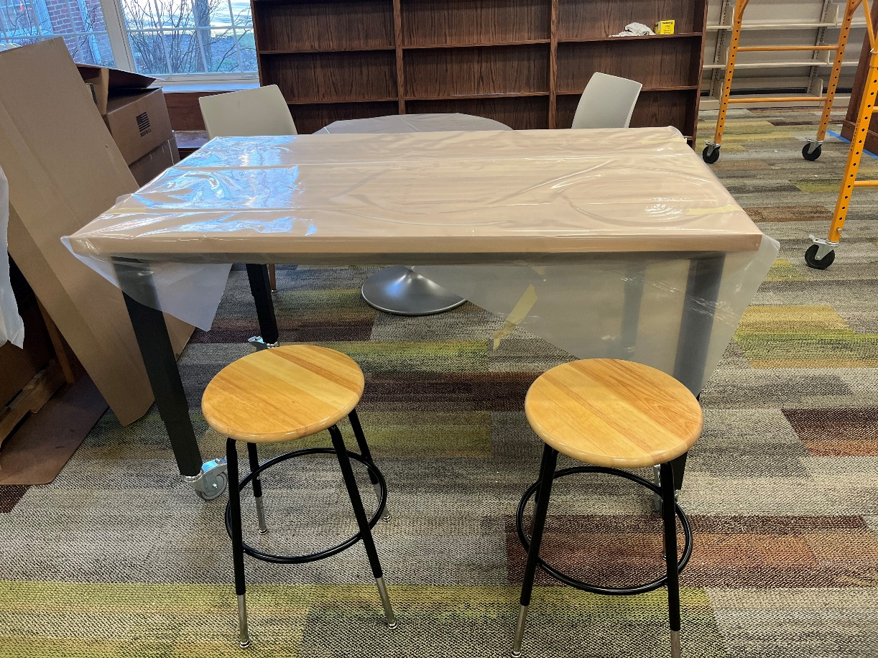
This table and stools will be in the Create Space
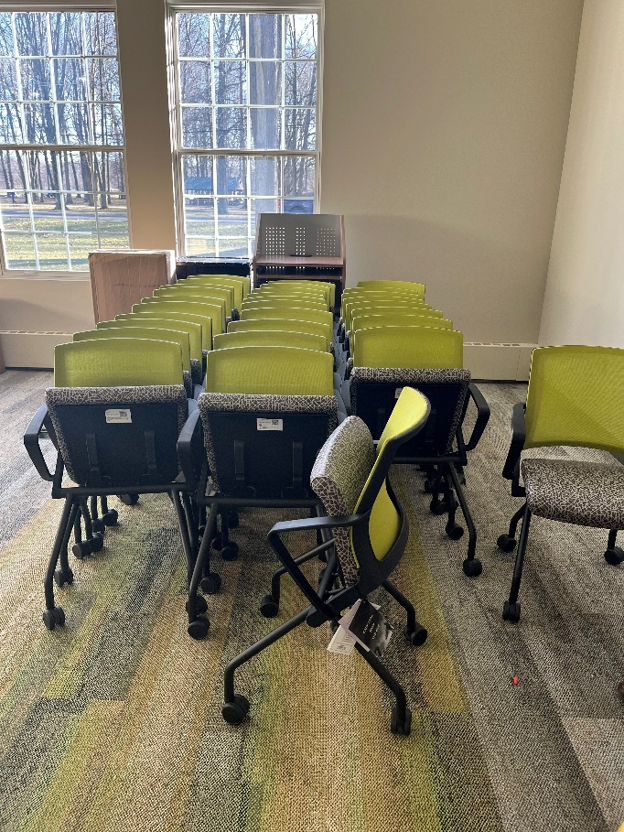 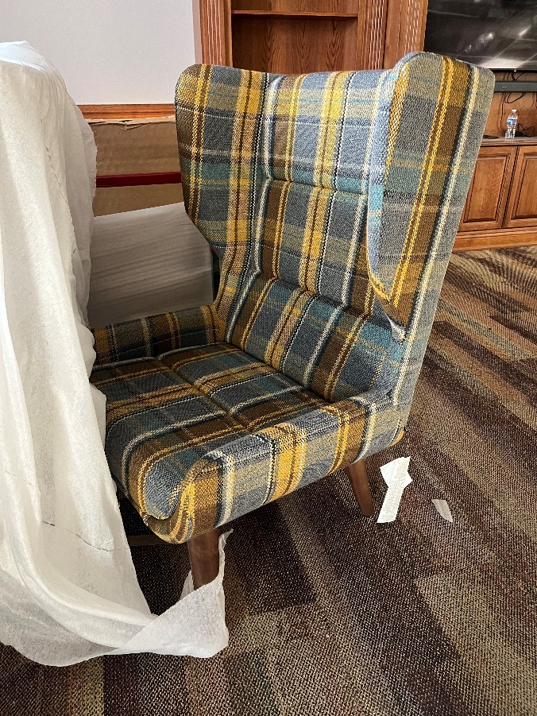
Meeting room chairs and one of the upholstered chairs for the Quiet Reading Room
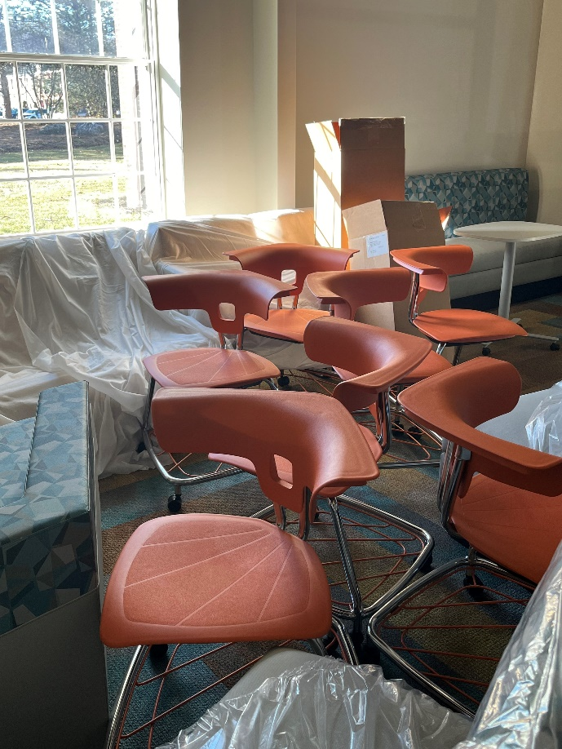 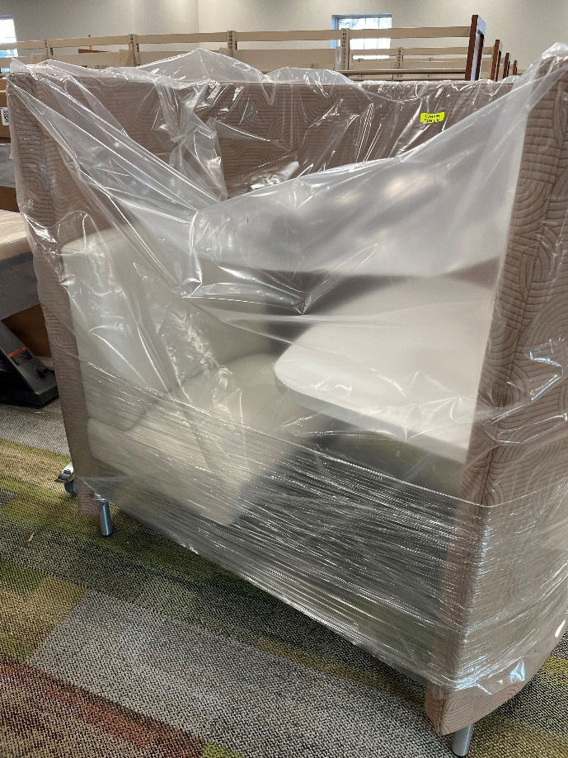
Chairs for the Teen Space and one of the new study pods
The North Ridgeville Branch has a levy, Issue 8, on the ballot in March. This levy is a renewal and will not raise taxes. It is the same levy that is on the ballot every five years; the ask has not changed in the past fifteen years.

The funds from the levy are 85% of the branch’s operating revenue which includes maintenance and upkeep of the building and grounds.

It is funds from past levies that are paying for the renovations you see here, and for the recent replacement of the 20-year-old roof. The funds were earmarked after the passage of the 2014 and 2019 levies but due to COVID-19 and supply chain issues, the project had been delayed.
As always, please contact the Branch Manager or Assistant Branch Manager with any questions or concerns.
Thank you for your patience through this process!

###

