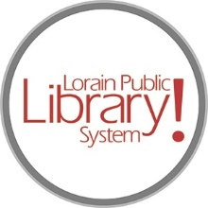
For more information, contact:
Jennifer Winkler, Branch Manager
JWinkler@lpls.info
or
Mark Peters, Assistant Branch Manager
MPeters@lpls.info
440-327-8326

LorainPublicLibrary.org

NORTH RIDGEVILLE PATRON UPDATE

December 19, 2023

In the Nov. 14 update, we told you that the crew would be starting on the interior window frames and that once those were done, the drywall would begin. Well, we’re happy to report that the window frames are now done and the drywall has begun! It is really starting to take shape.

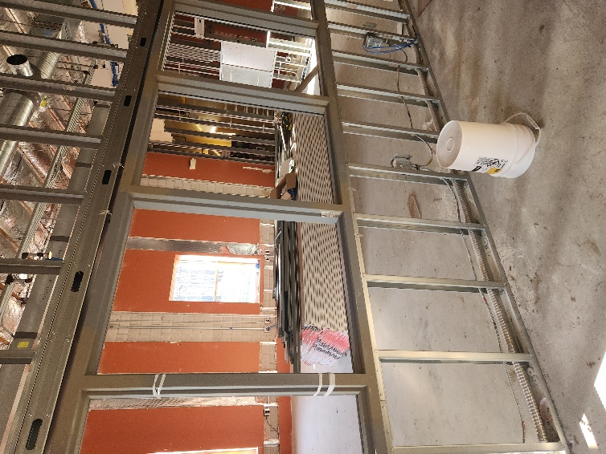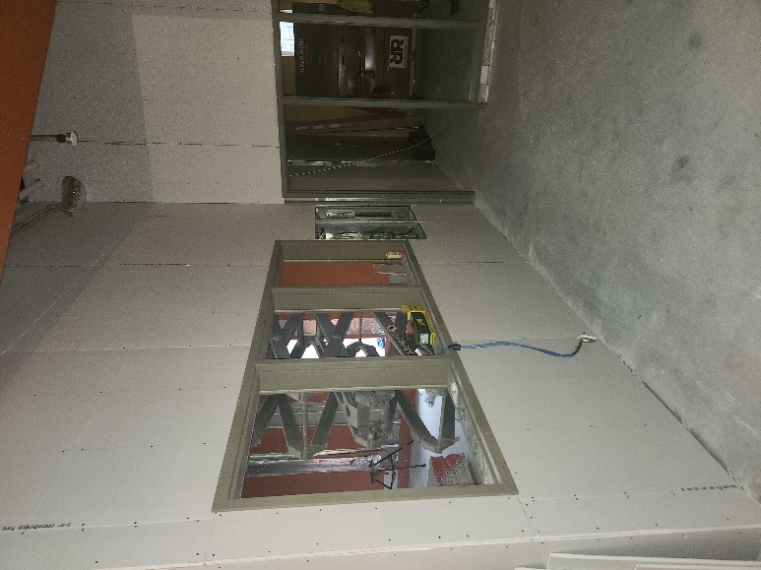
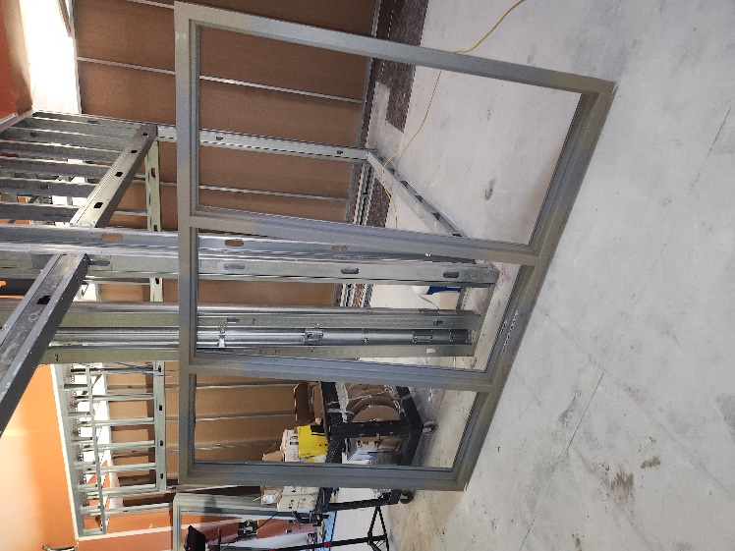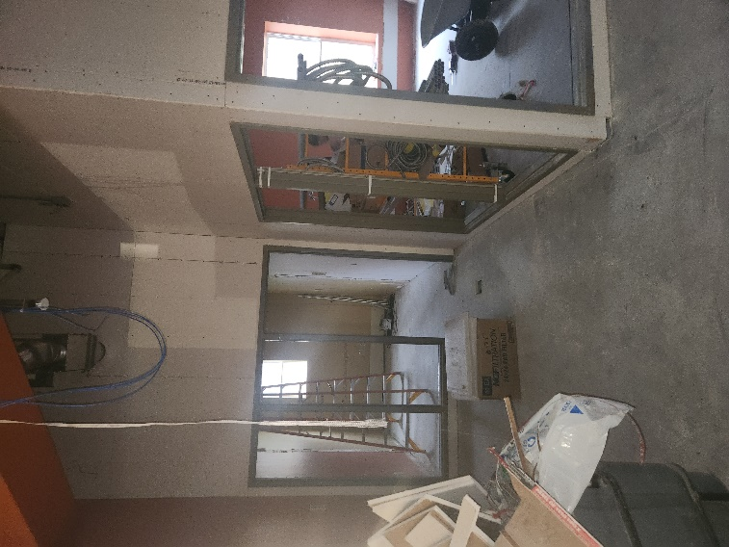

As always, please contact the Branch Manager or Assistant Branch Manager with any questions or concerns.
Thank you for your patience through this renovation process!

###

