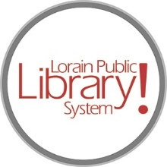

*For more information, contact:*

Jennifer Winkler, Branch Manager

[JWinkler@lpls.info](mailto:JWinkler@lpls.info)

or

Mark Peters, Assistant Branch Manager

[MPeters@lpls.info](mailto:MPeters@lpls.info)

440-327-8326

[LorainPublicLibrary.org](http://www.lorainpubliclibrary.org/)

**NORTH RIDGEVILLE PATRON UPDATE**

August 29, 2023

The temporary construction wall is up!

Please contact the Branch Manager or Assistant Branch Manager with any questions or concerns. Thank you for your patience through this renovation process!

###[](https://www.tiktok.com/discover/lorainplsystem)[](https://twitter.com/LorainPLSystem)[](https://www.facebook.com/LorainPublicLibrarySystem/)[](https://www.instagram.com/LorainPLSystem/)