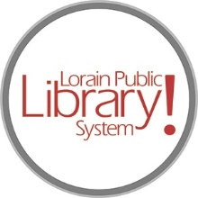
For more information, contact:
Jennifer Winkler, Branch Manager
JWinkler@lpls.info
or
Mark Peters, Assistant Branch Manager
MPeters@lpls.info
440-327-8326

LorainPublicLibrary.org

NORTH RIDGEVILLE PATRON UPDATE

April 3, 2024
Staff have been busy the last two weeks as the renovation project is moving forward and about to enter phase 3 demolition.
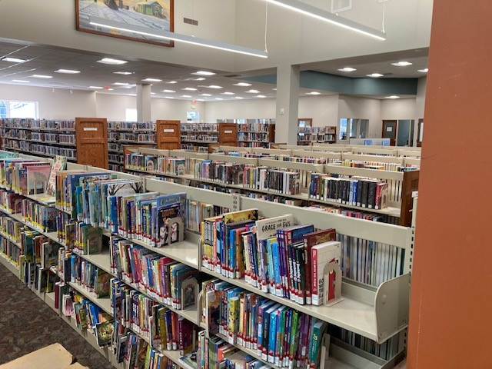
The entire adult collection, teen collection and some of the children's collection was moved to the south end of the library.

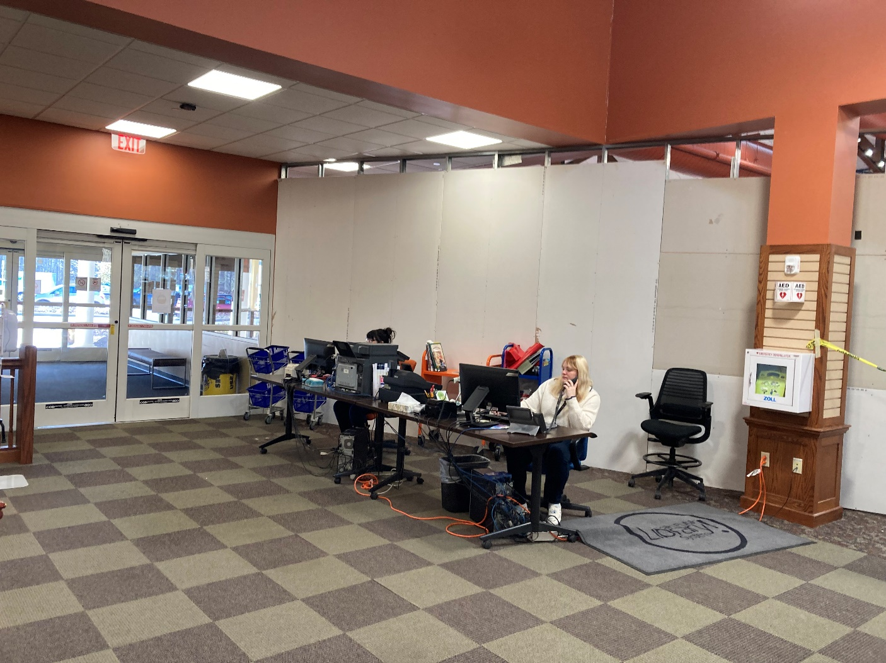
A temporary mobile circulation station has been set up as the current circulation desk will be removed.
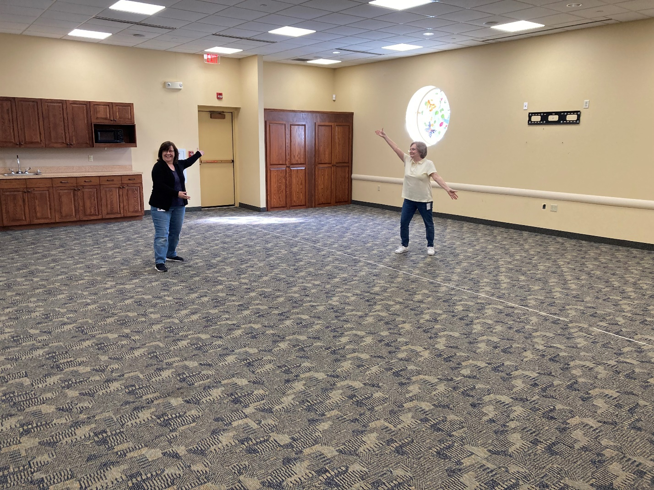
Everything in meeting rooms A and B was packed up and moved out so the crew can lay new carpet and paint.
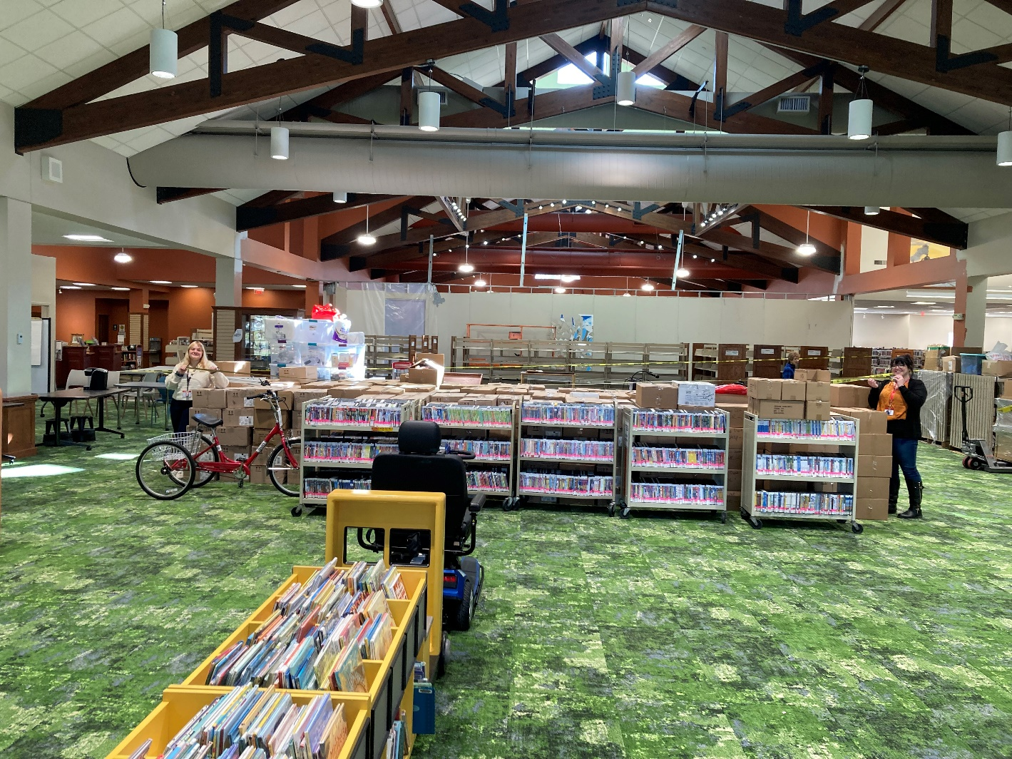
New shelving will be assembled and put in place this week and we will begin unpacking the children's collection and start to shelve and reassemble the children's area.
Programming has resumed and story times are in full swing!
We are so very appreciative of your continued support!
As always, please contact the Branch Manager or Assistant Branch Manager with any questions or concerns.
Thank you for your patience through this process!

###

