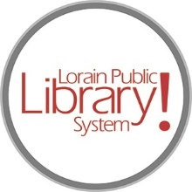

*For more information, contact:*

Anne Godec, Branch Manager

[AGodec@lpls.info](mailto:AGodec@lpls.info)

or

Mark Peters, Assistant Branch Manager

[MPeters@lpls.info](mailto:MPeters@lpls.info)

440-327-8326

[LorainPublicLibrary.org](http://www.lorainpubliclibrary.org/)

**NORTH RIDGEVILLE PATRON UPDATE**

April 30, 2024  
  
It has been a busy month!

The old circulation desk was removed. A new circulation desk is being built and will be installed closer to the center of the branch.

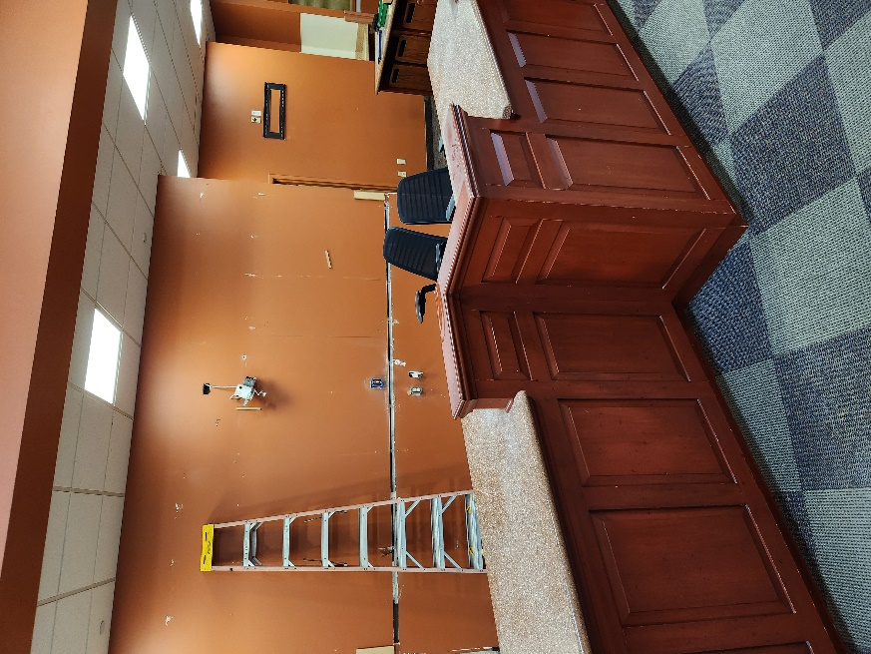 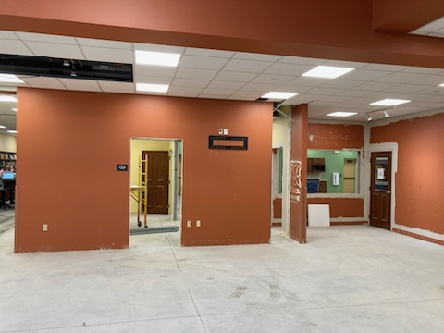

Now you see it Now you don’t!

The construction crew removed the carpet from the main area, entryway and meeting rooms on the north end of the building. It took some doing as it had been glued down, so the old glue had to be sanded off prior to the new carpet being laid. It was the sanding of the old glue that led to a rather dusty situation throughout the branch – please pardon our mess! Also a trench was cut into the floor to run electrical. There wasn’t as much “tech” when the branch was built; this trench is necessary for all of the updated technology and additional outlets for patron’s personal devices.

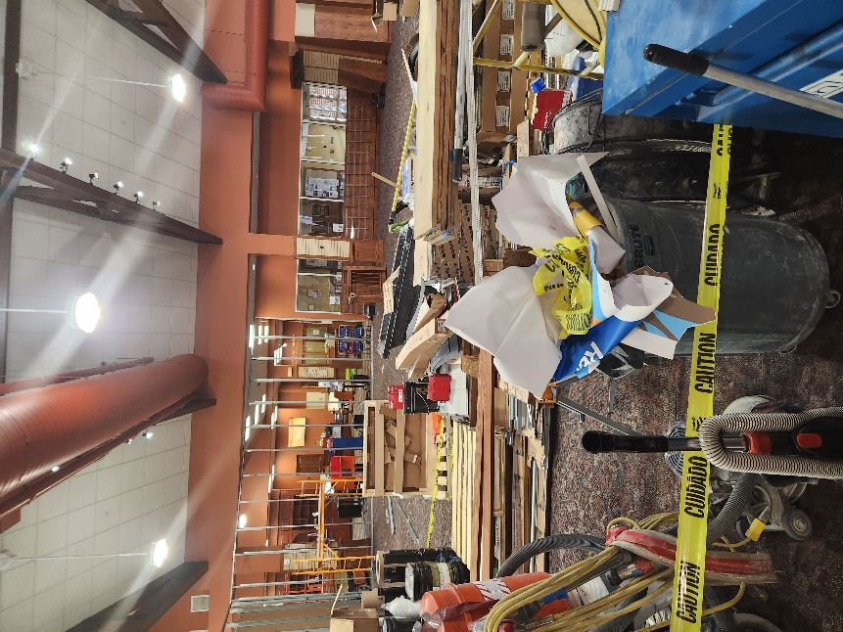 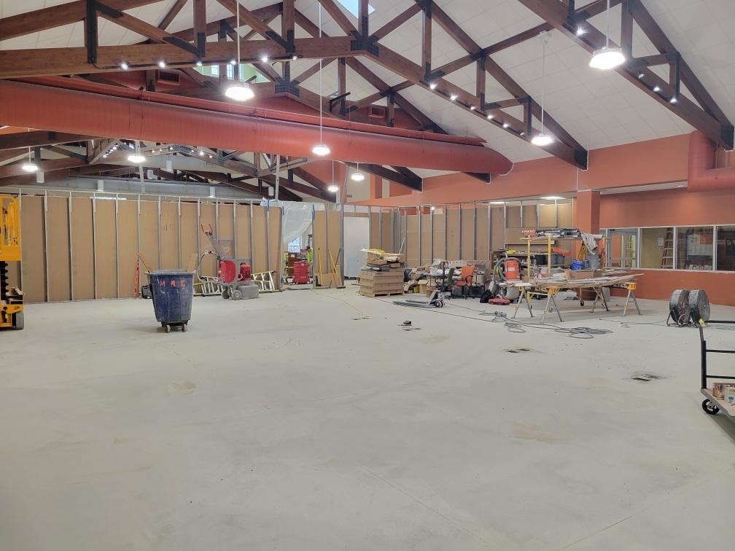

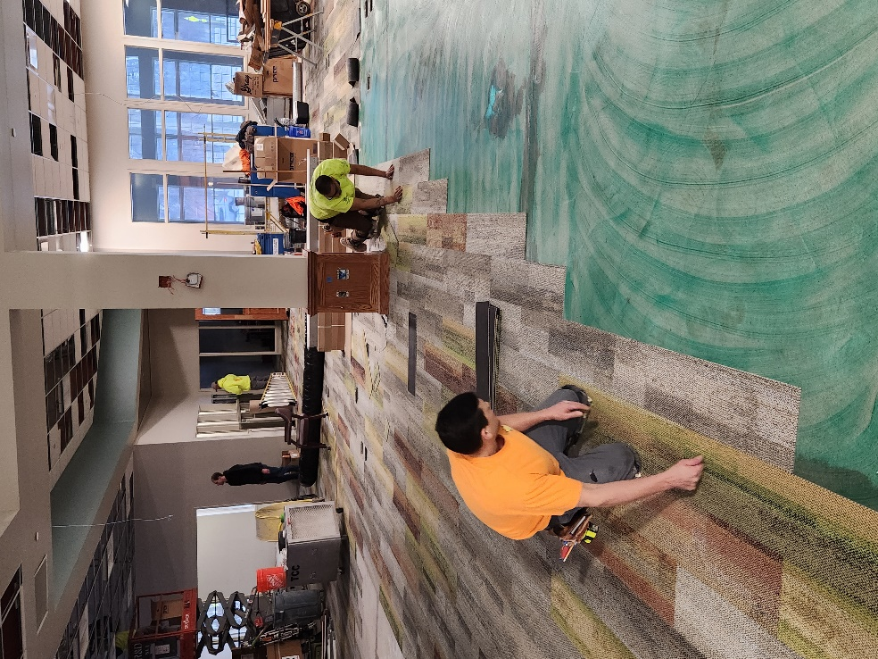 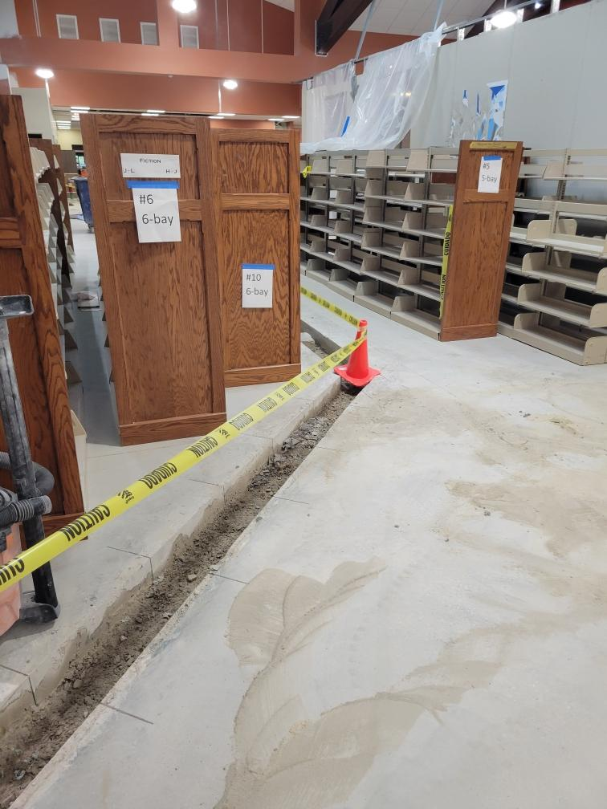

The carpet install and paint are being finished and things will move faster once those are complete.

Programming has resumed and story times are in full swing. Summer program registrations will open May 15 for all programs except those in the Create Space. Registrations for the Create Space programs at the North Ridgeville Branch will open June 15.

We are happy to announce that the North Ridgeville Branch will be the kickoff location for the Chamber’s annual Discover the Ridge event on Saturday, May 18! We have a carnival-theme event planned including games, Spring Mist Farms petting zoo and Twister Girl Balloon Company!

We are so very appreciative of your continued support!

As always, please contact the Branch Manager or Assistant Branch Manager with any questions or concerns.

Thank you for your patience through this process!

###