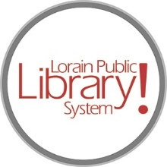
For more information, contact:
Jennifer Winkler, Branch Manager
JWinkler@lpls.info
or
Mark Peters, Assistant Branch Manager
MPeters@lpls.info
440-327-8326

LorainPublicLibrary.org

NORTH RIDGEVILLE PATRON UPDATE

August 4, 2023

Out with the old
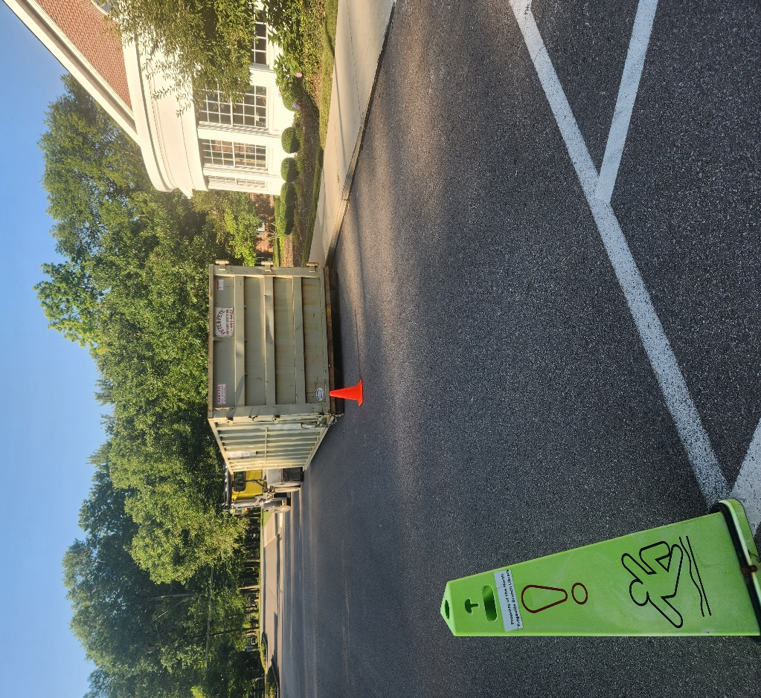
A dumpster has been placed in the parking lot and a crew will be brought in after closing on Monday, August 7, to remove the old shelving and A-frames that we will no longer be using and weren’t able to sell or donate.
Please contact the Branch Manager or Assistant Branch Manager with any questions or concerns.
Thank you for your patience through this renovation process!
###

