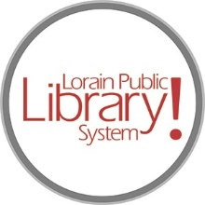

*For more information, contact:*

Jennifer Winkler, Branch Manager

[JWinkler@lpls.info](mailto:JWinkler@lpls.info)

or

Mark Peters, Assistant Branch Manager

[MPeters@lpls.info](mailto:MPeters@lpls.info)

440-327-8326

[LorainPublicLibrary.org](http://www.lorainpubliclibrary.org/)

**NORTH RIDGEVILLE PATRON UPDATE**

November 21, 2023

The new roof is going on! The drive thru will need to be closed on Monday, November 27 and Tuesday, November 28 for the safety of our patrons and construction crew while they complete this project.

This should be the last of the exterior work.

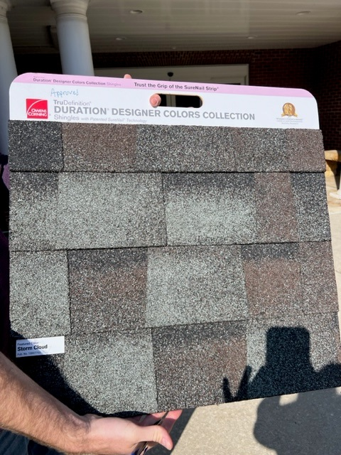

As always, please contact the Branch Manager or Assistant Branch Manager with any questions or concerns.

Thank you for your patience through this renovation process!

###[](https://www.tiktok.com/discover/lorainplsystem)[](https://twitter.com/LorainPLSystem)[](https://www.facebook.com/LorainPublicLibrarySystem/)[](https://www.instagram.com/LorainPLSystem/)